**ITT-340 PEN Testing Report Guidelines**

**Direction:** Use this example as a guideline to build your PEN Testing Report.

**Cover Page**

This is the start of your document and is used to impress the customer, so be creative. Create a cover page that is unique to your select organization.Follow GCU’s APA Writing Guide for the proper format of a standard cover page**.**

**Document Properties**

This section is used to document any revisions to the report and who performed them. Additionally, this section documents the original author of the report.

| **Title** | Benchmark -Penetration Assessment |
| --- | --- |
| **Author** | Liela Pressley |

**Versioning Control**

| **Version** | **Date** | **Author** | **Changes** |
| --- | --- | --- | --- |
| 01 | 3/03/2024 | Liela Pressley |  |

**Disclaimer:** This document and its findings is a purely fictitious penetration testing report for the purpose of learning and training. All reconnaissance, password cracking, and exploiting was done in a sandbox environment consisting of virtual machines and does not represent any actual networks or systems of any organization.

**Executive Summary**

The penetration test consisted of recon using tools such as Nmap and vulnerability assessment tools such as metasploitable and legion. Due to unexpected storage errors and errors within Legion, I was able to exploit a vulnerability through manual commands such as niktos.

**Table of Contents**

**VM S1.100**

**VM S1.110**

**VM S1.140**

**VM S1.120**

**Phase Testing (Main Headings)**

**VM S1.100**

*Starting with launching the S1.100 VM, I started using nmap to scan for open ports and protocols within the machine and ot make sure that it was running.*

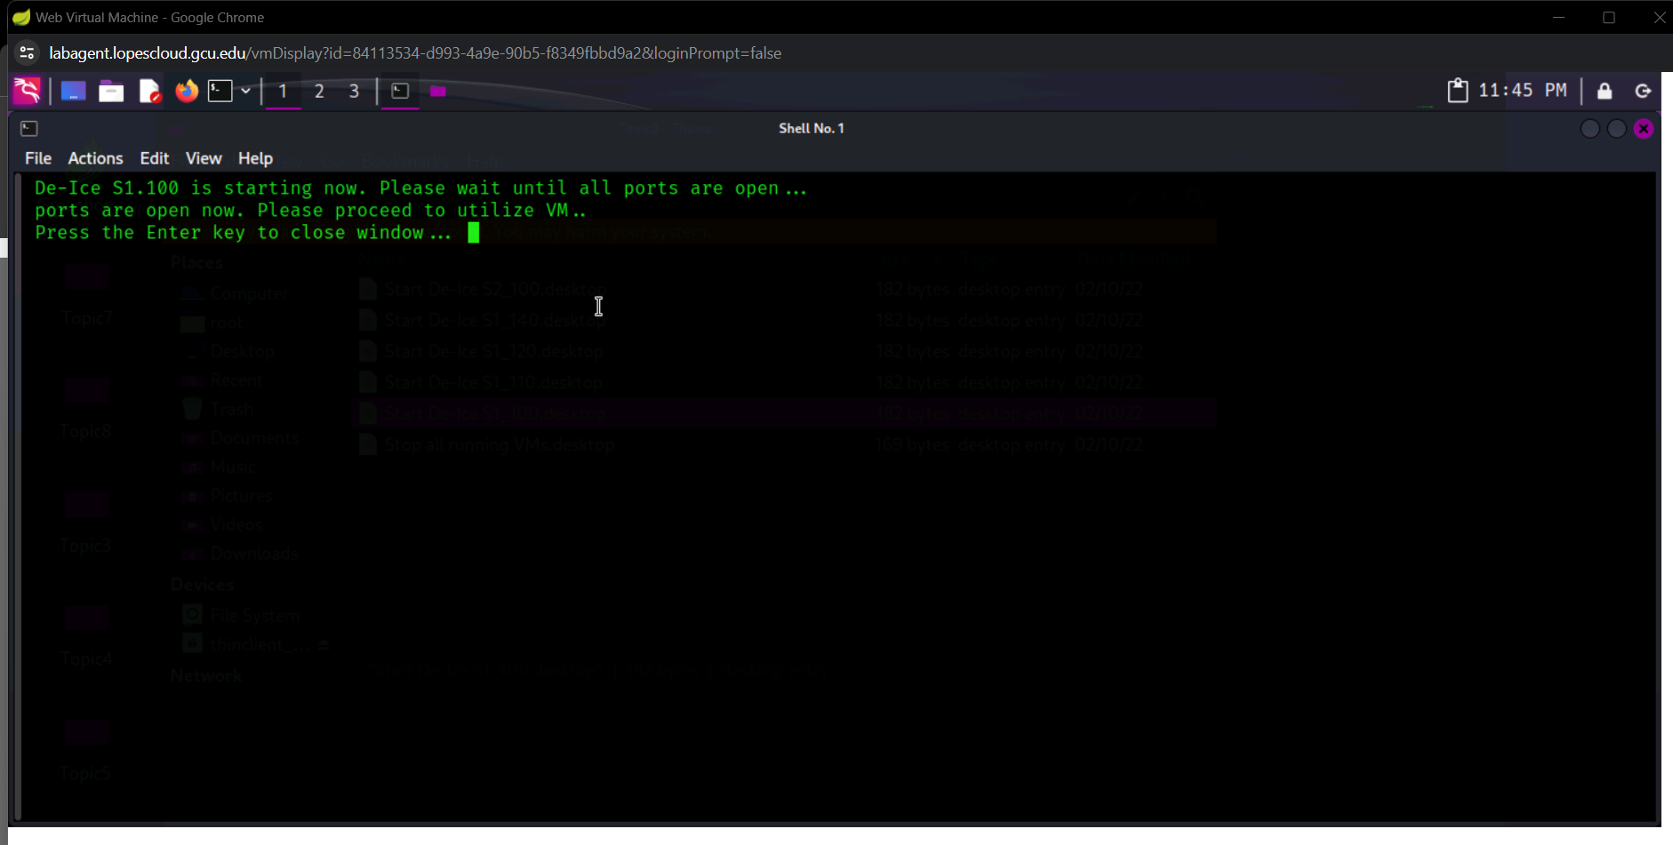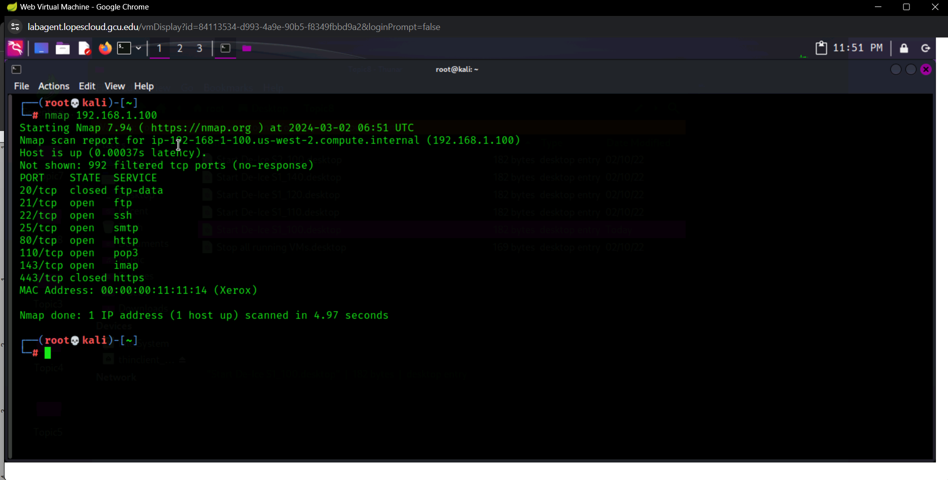

*Then with the ip a command wanted to check if it was running a different way.*

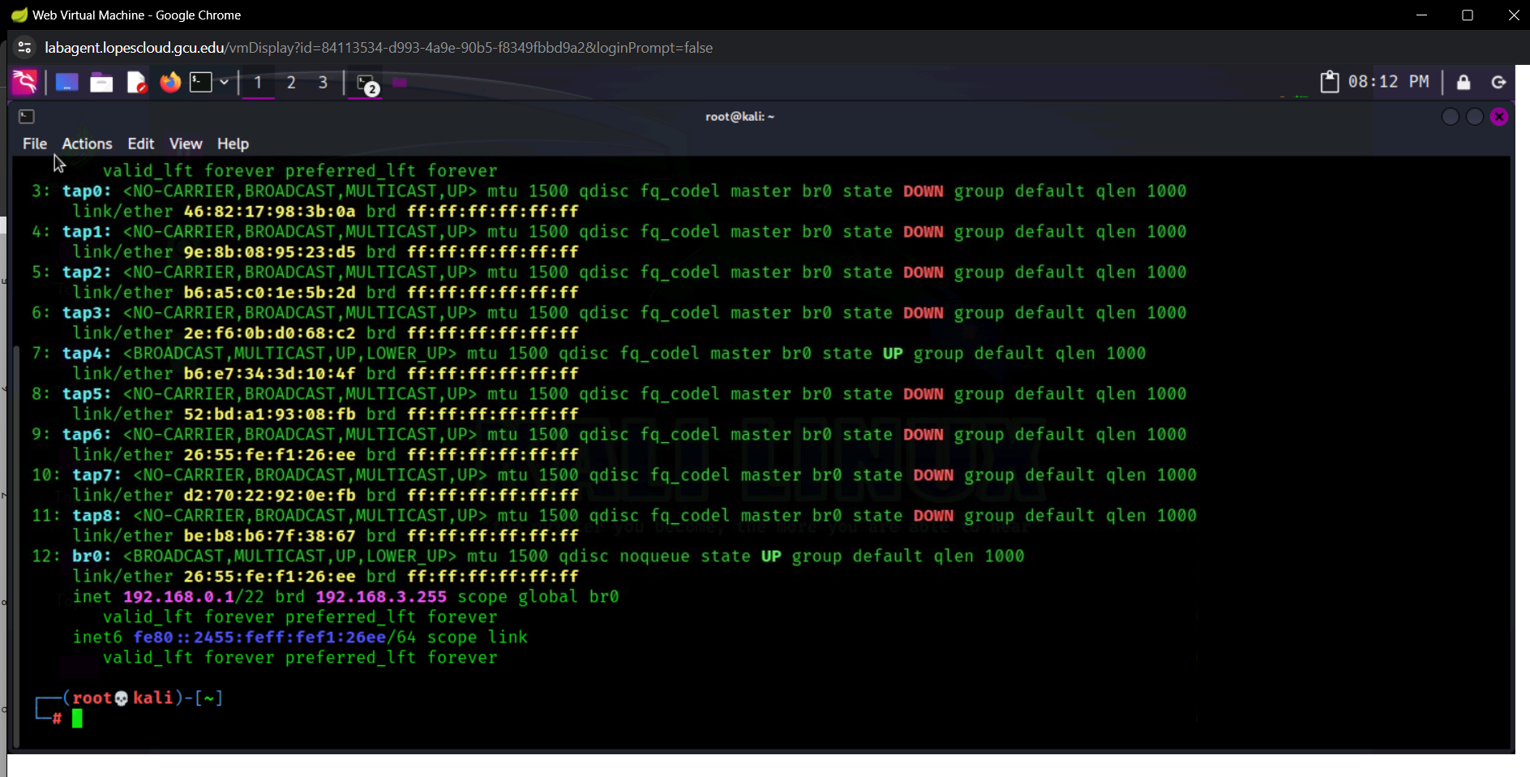

*When i tried to install and launch legion I received the error that I didn’t have enough storage available in the /var/cache/apt/archives/. I tried exiting the VM, exiting LopesCloud and restarting and it wouldn’t work after multiple tries*

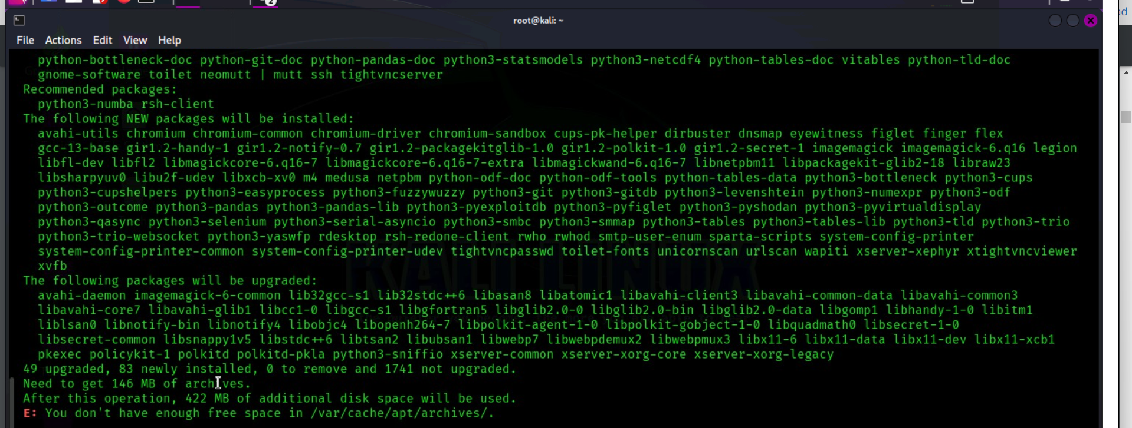

*I resorted to trying to delete some files with hopes that I was removing duplicates or “unnecessary files” so it would allow me to download and run Legion. It did allow me to download it due to the free space but unfortunately, it required the same files I deleted.*

*I was able to download some of the files manually and then resorted to the command: apt-get update to restore most of the files that it needed for Legion to at least launch and function.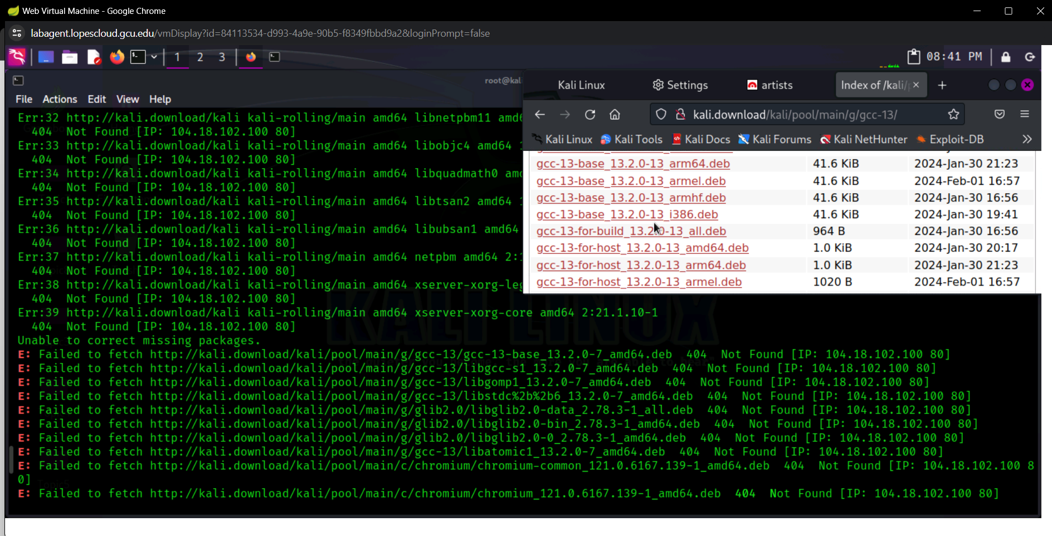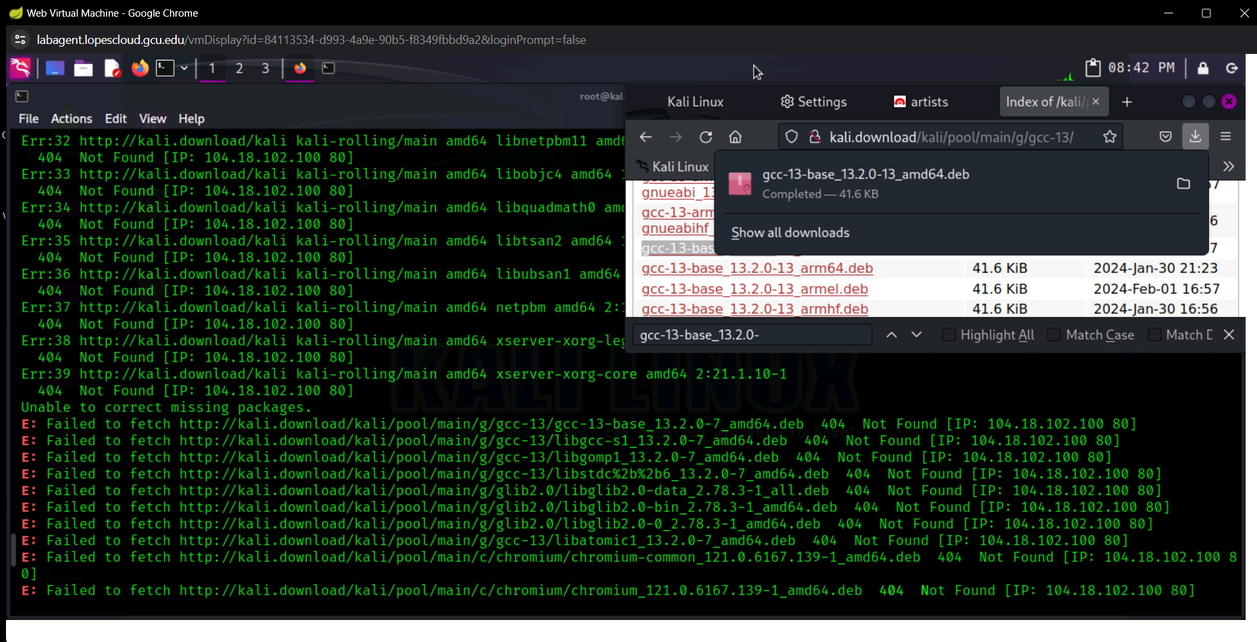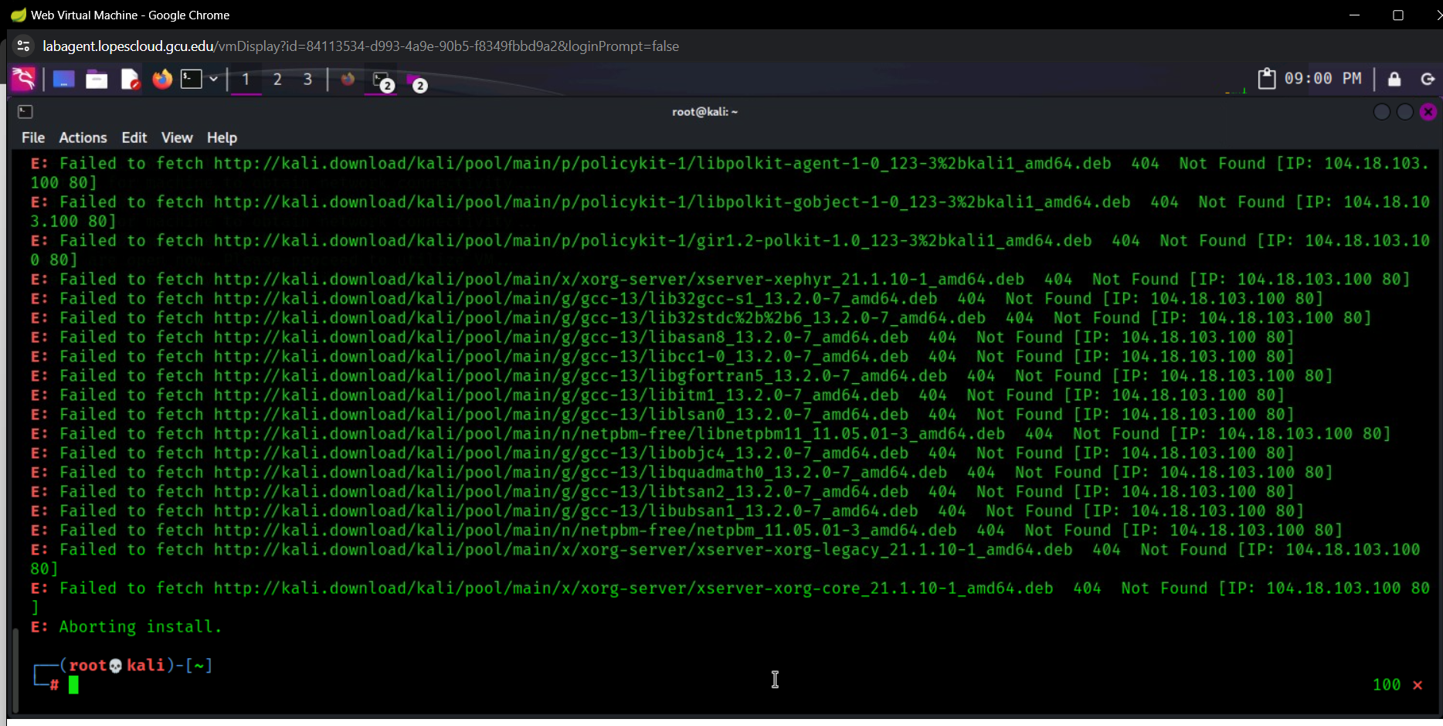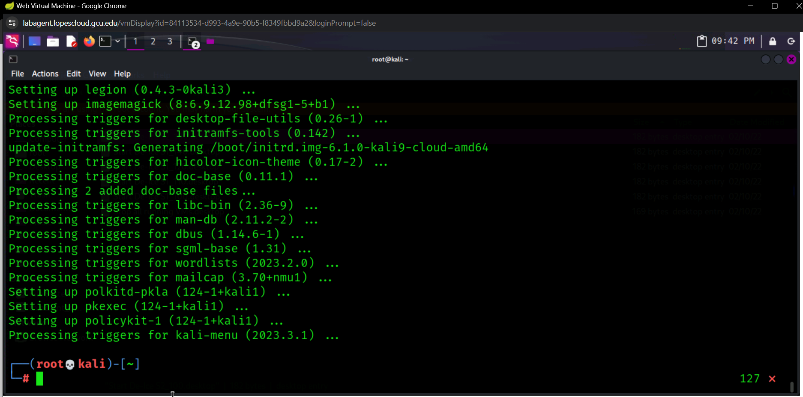*

*After typing in legion as a command the following showed up to which i entered the IP address of the VM that I wanted to test (192.168.0.100):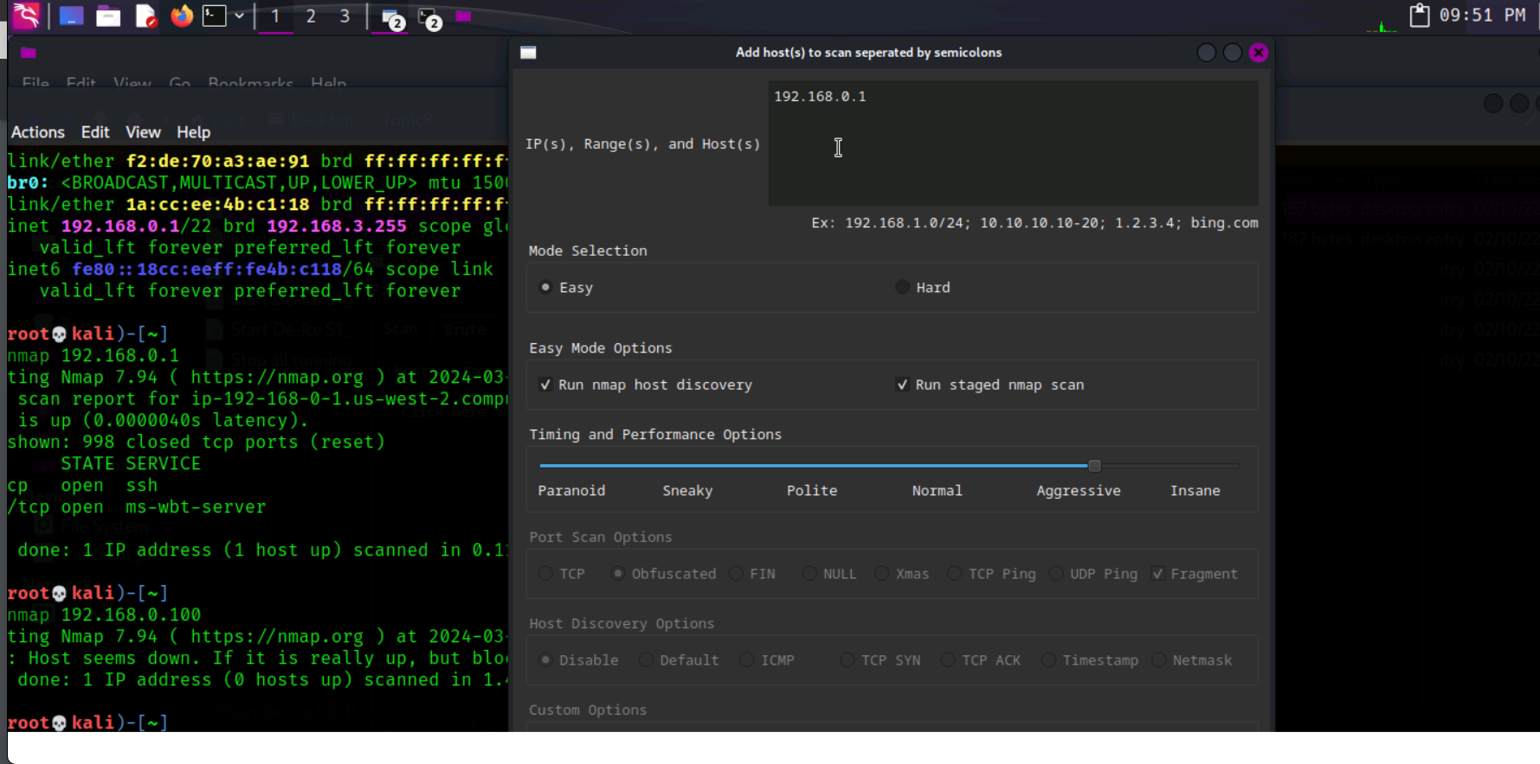*

*After submitting the IP address it started scanning and implementing different tools such as nmap.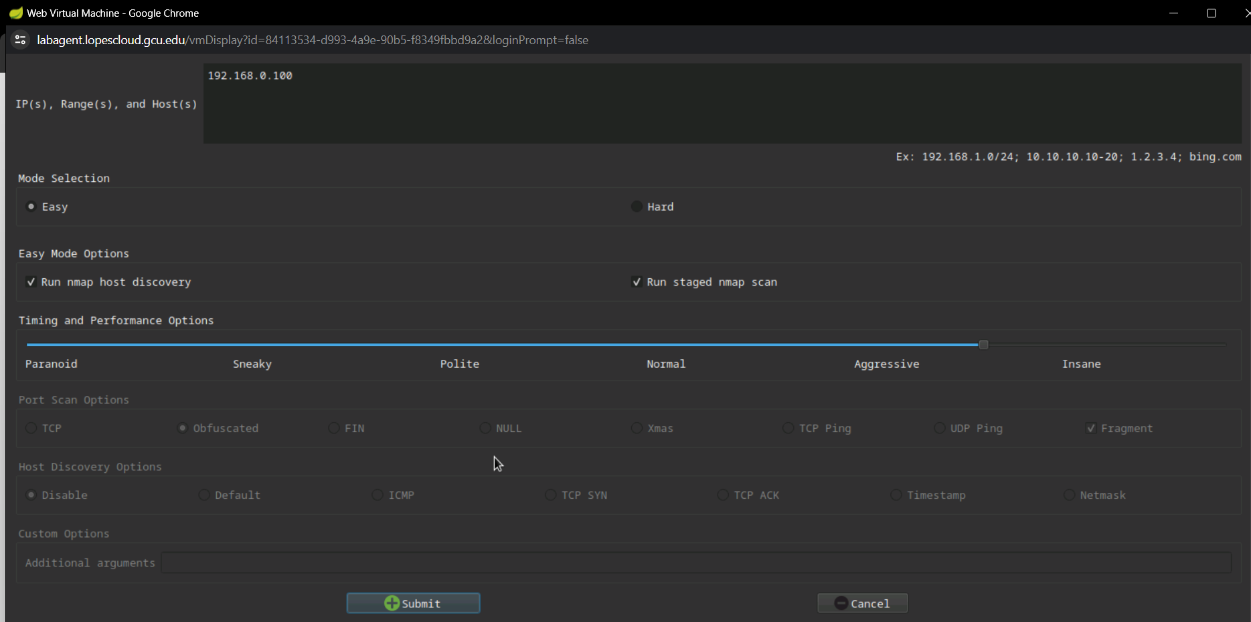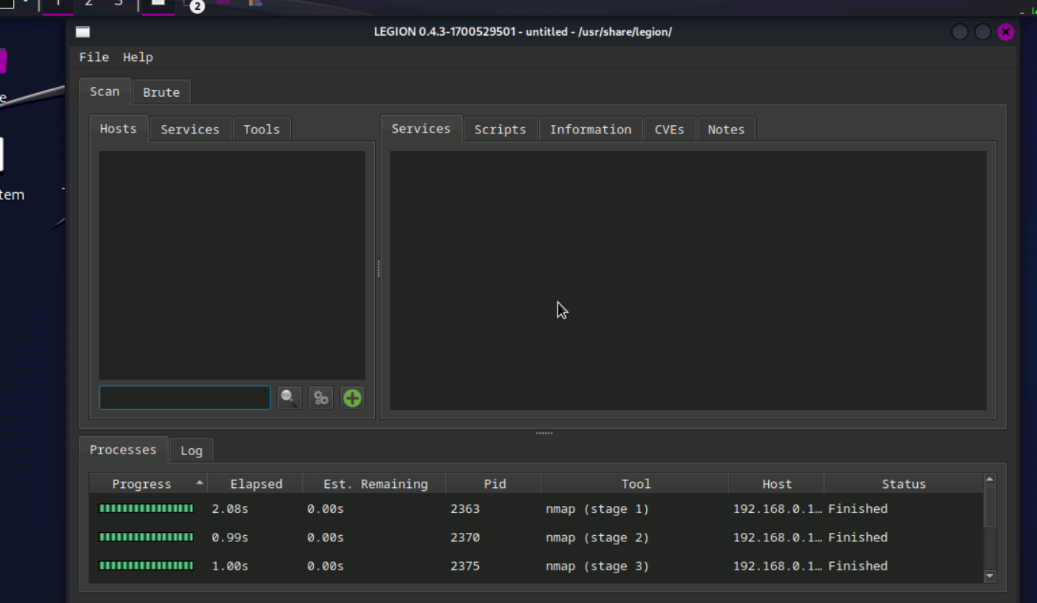I*

*It started providing the different open ports along with the services that are using them and a list of CVE vulnerabilities found with the IP address. Unfortunately, the niktos didn’t work 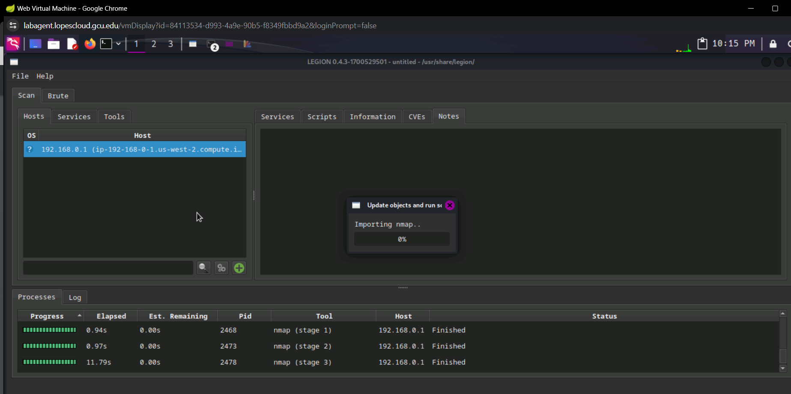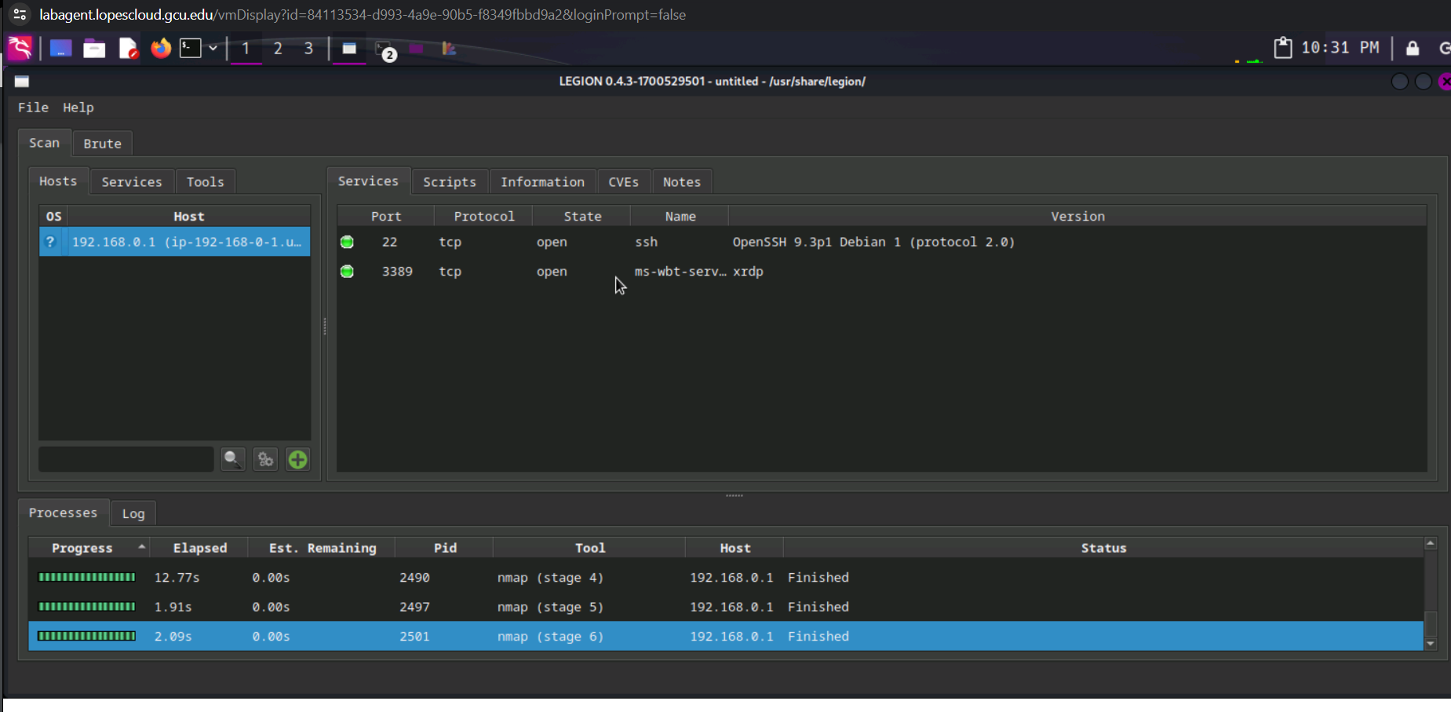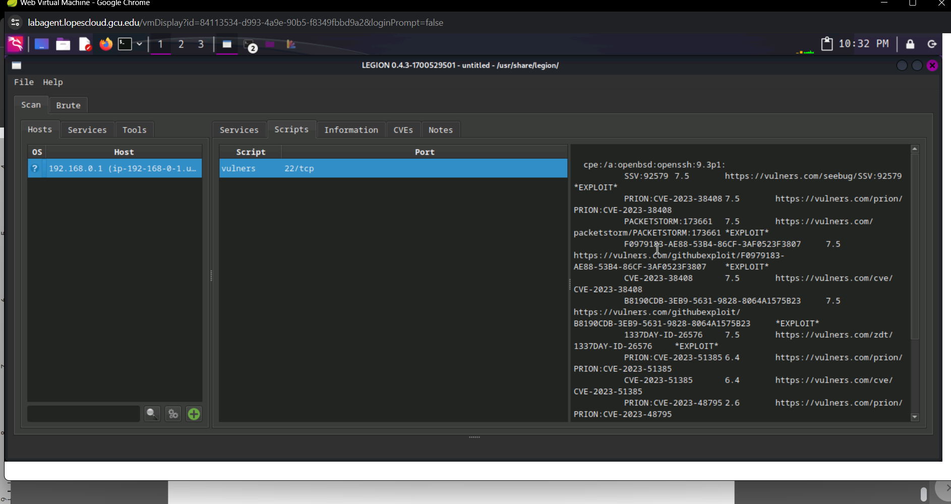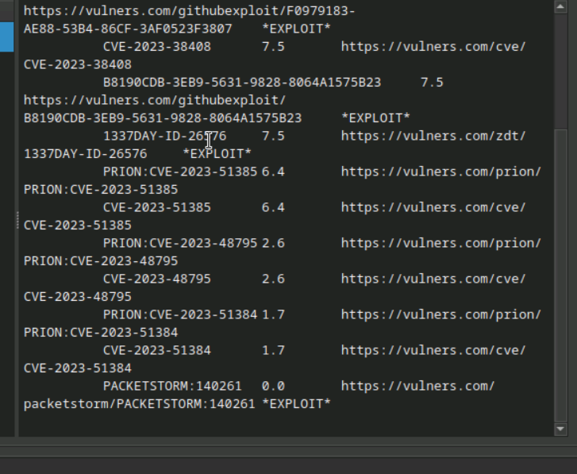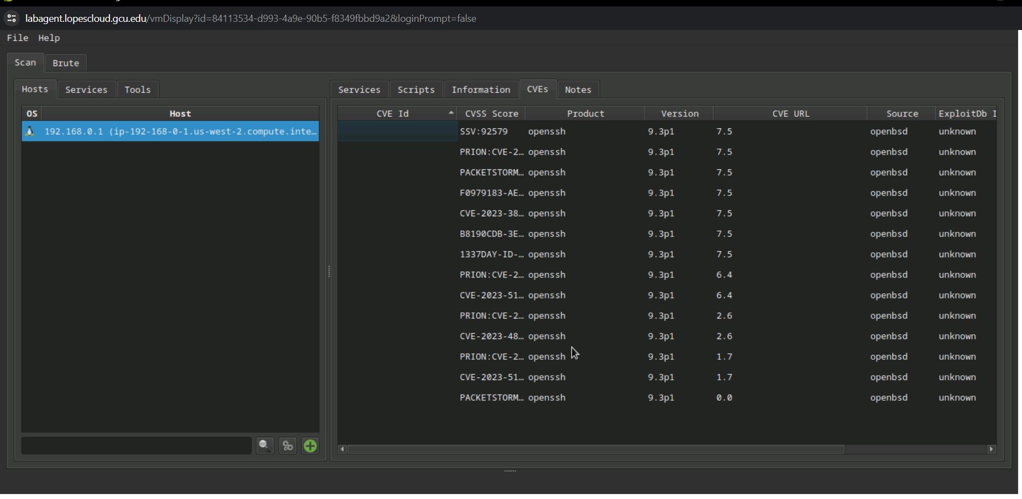*

*Was able to also see the OS that this machine is align with the amount of ports that are open/closed and filtered*

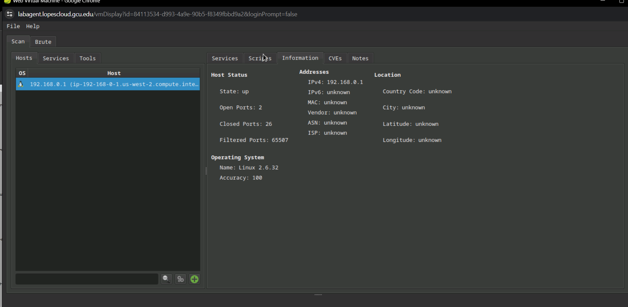

*Due to the fact that the nikto didn’t automatically pop up on the legion automatically I tried to run it manually which didn’t work even when i tried different tools.****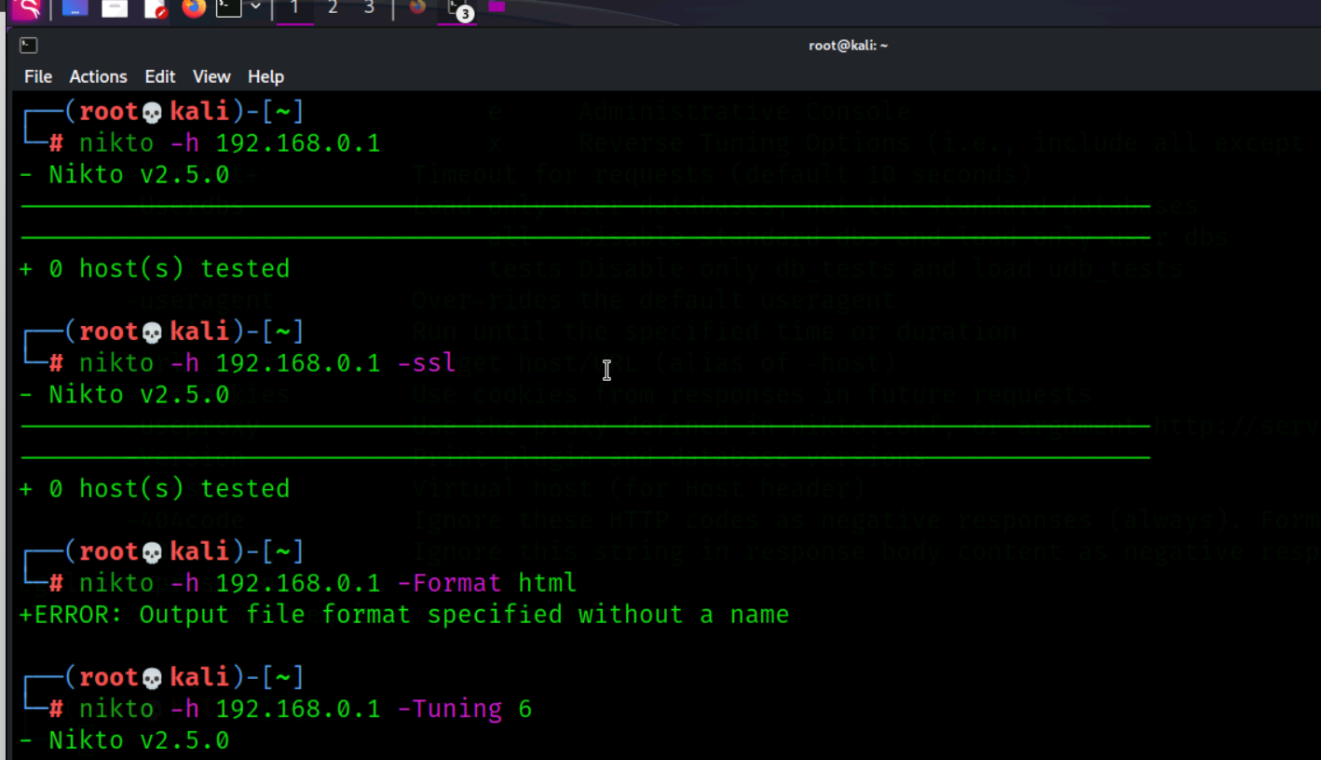***

**VM S1.110**

After launching the 110 VM I checked it via nmap to make sure that it was running and to see what basic recon I can find from doing a scan.

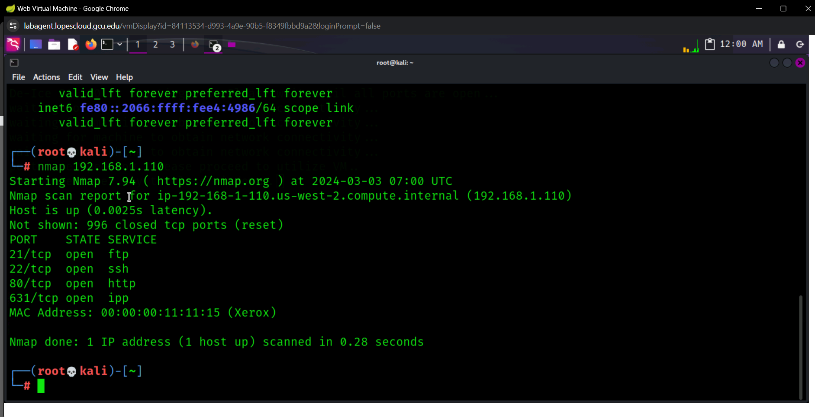When I tried to launch legion and entered the IP address of this VM it would scan for a few seconds before crashing and displaying this error message. So I decided to try some manual practices.

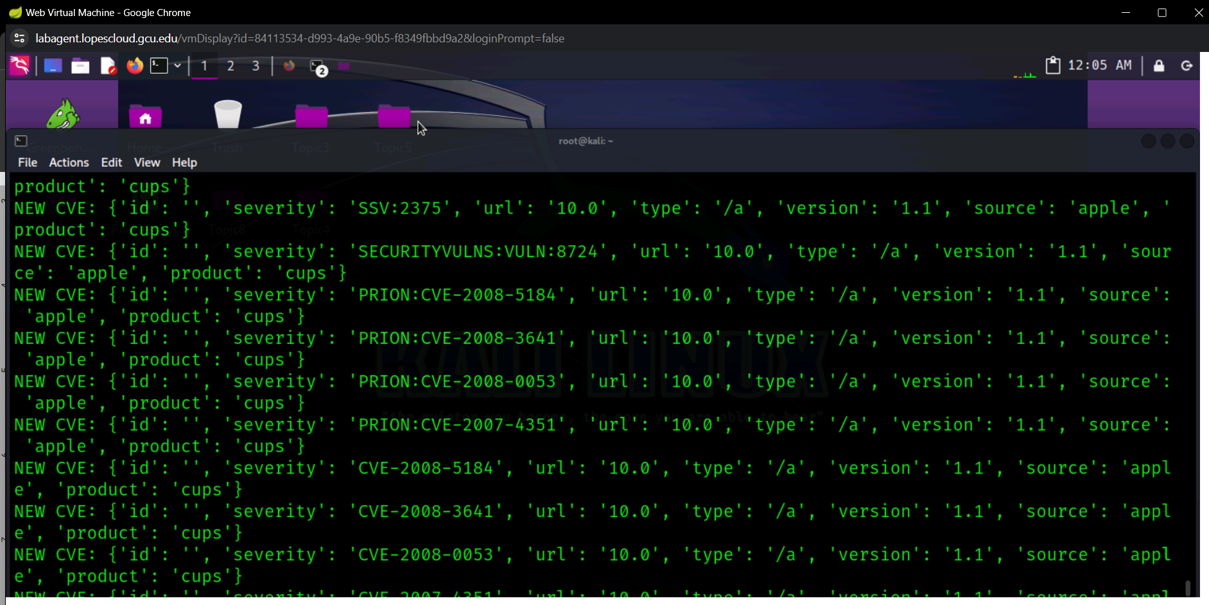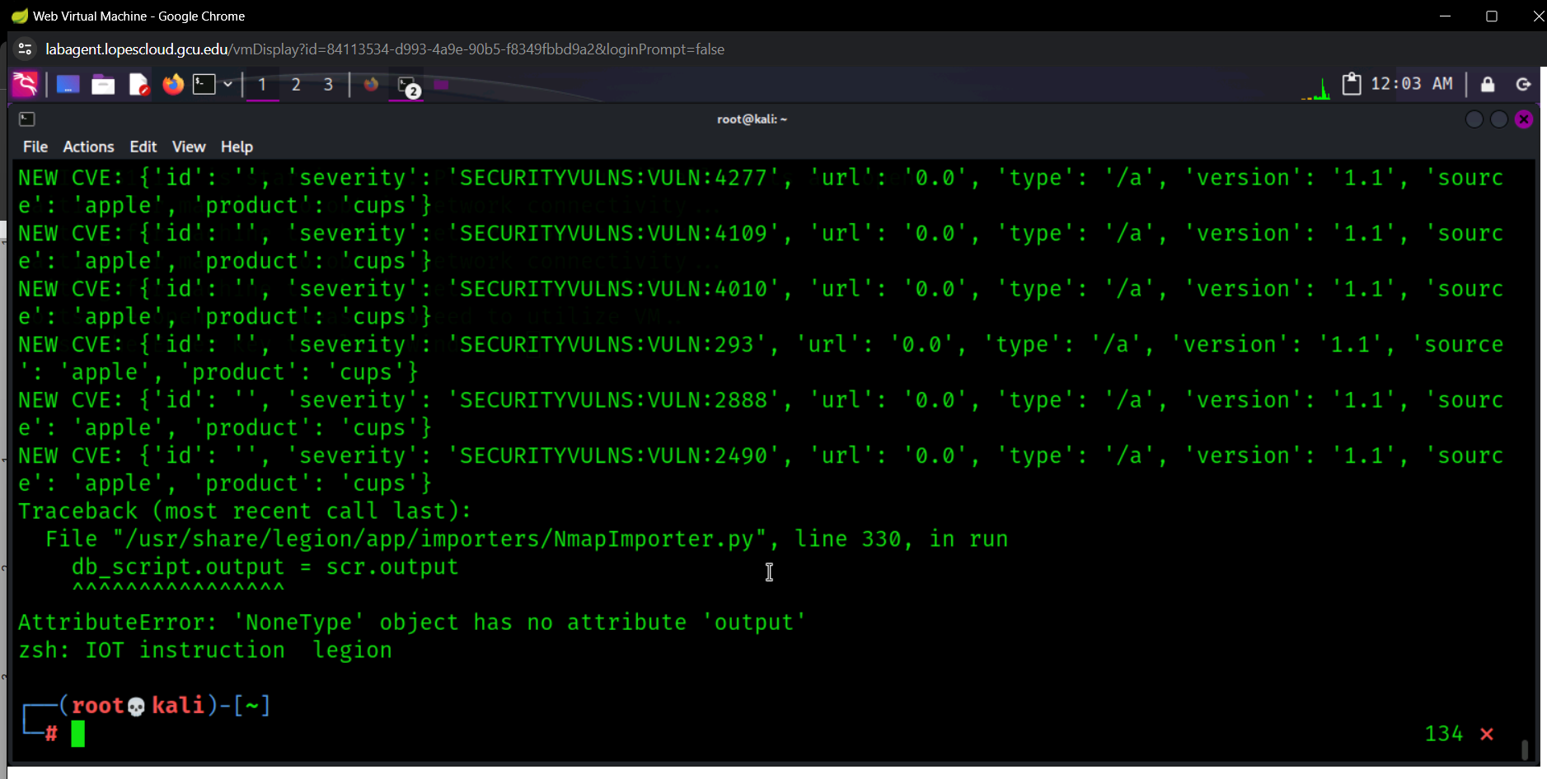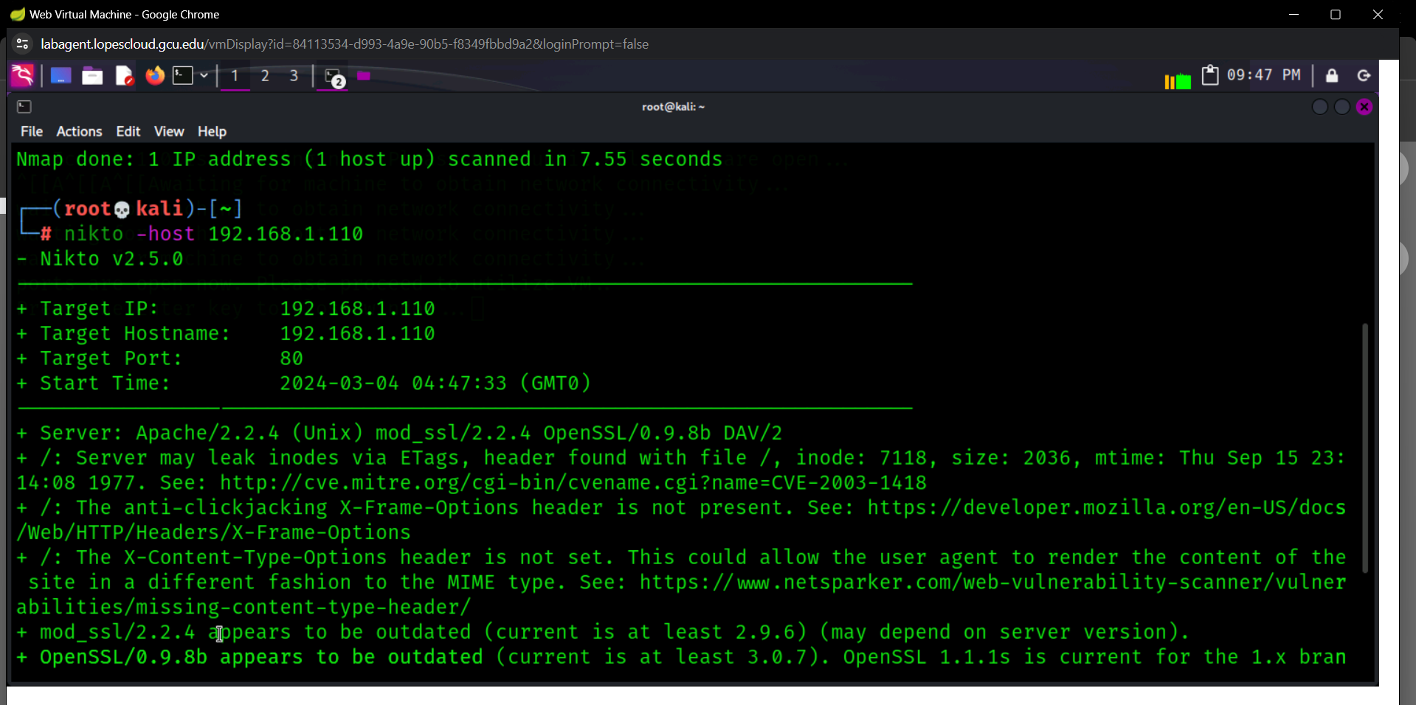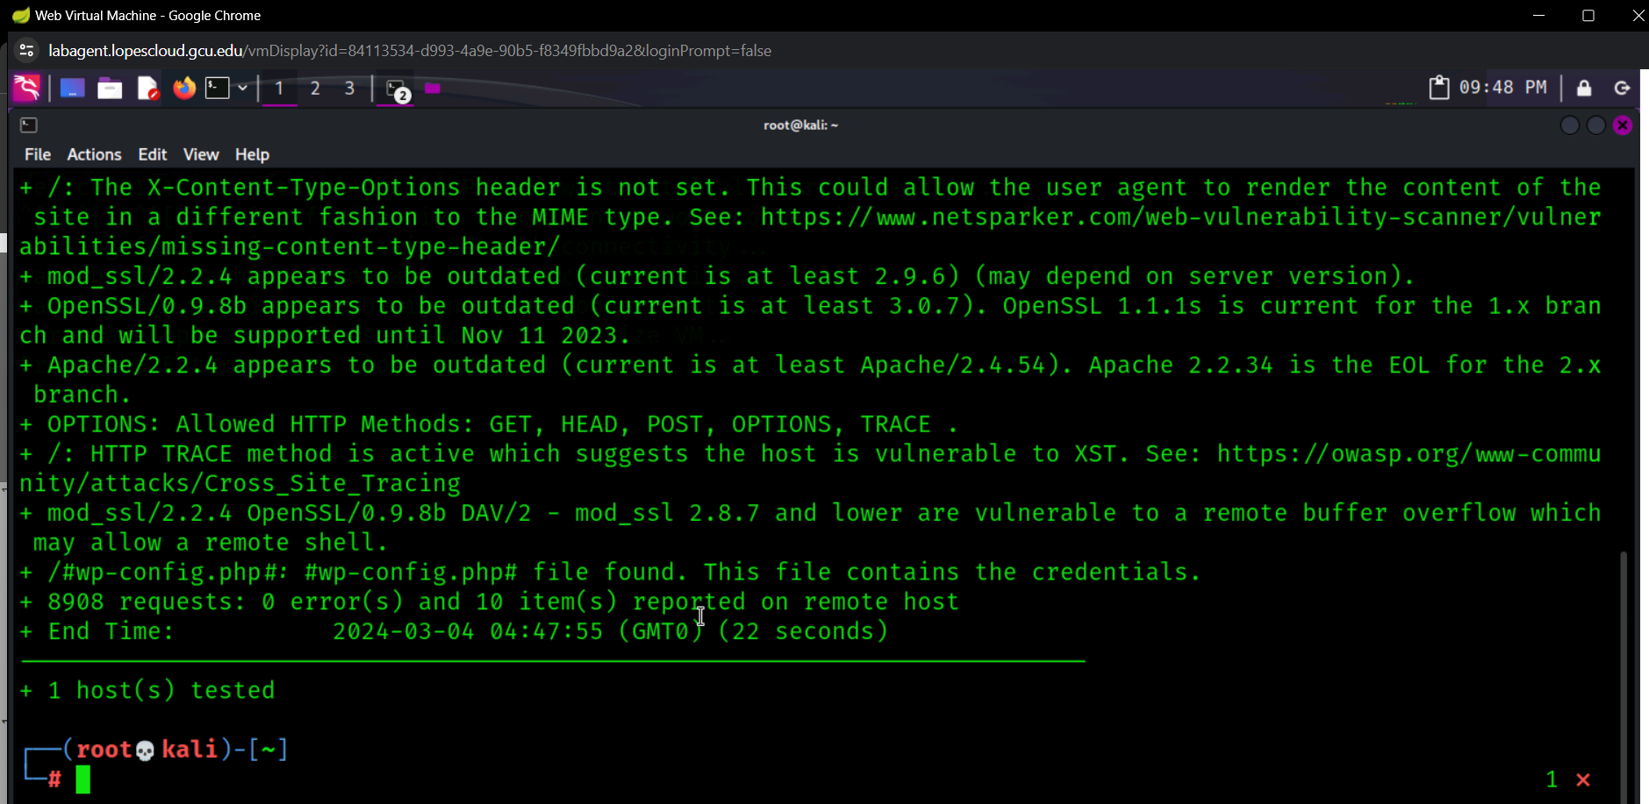

**S1.120**

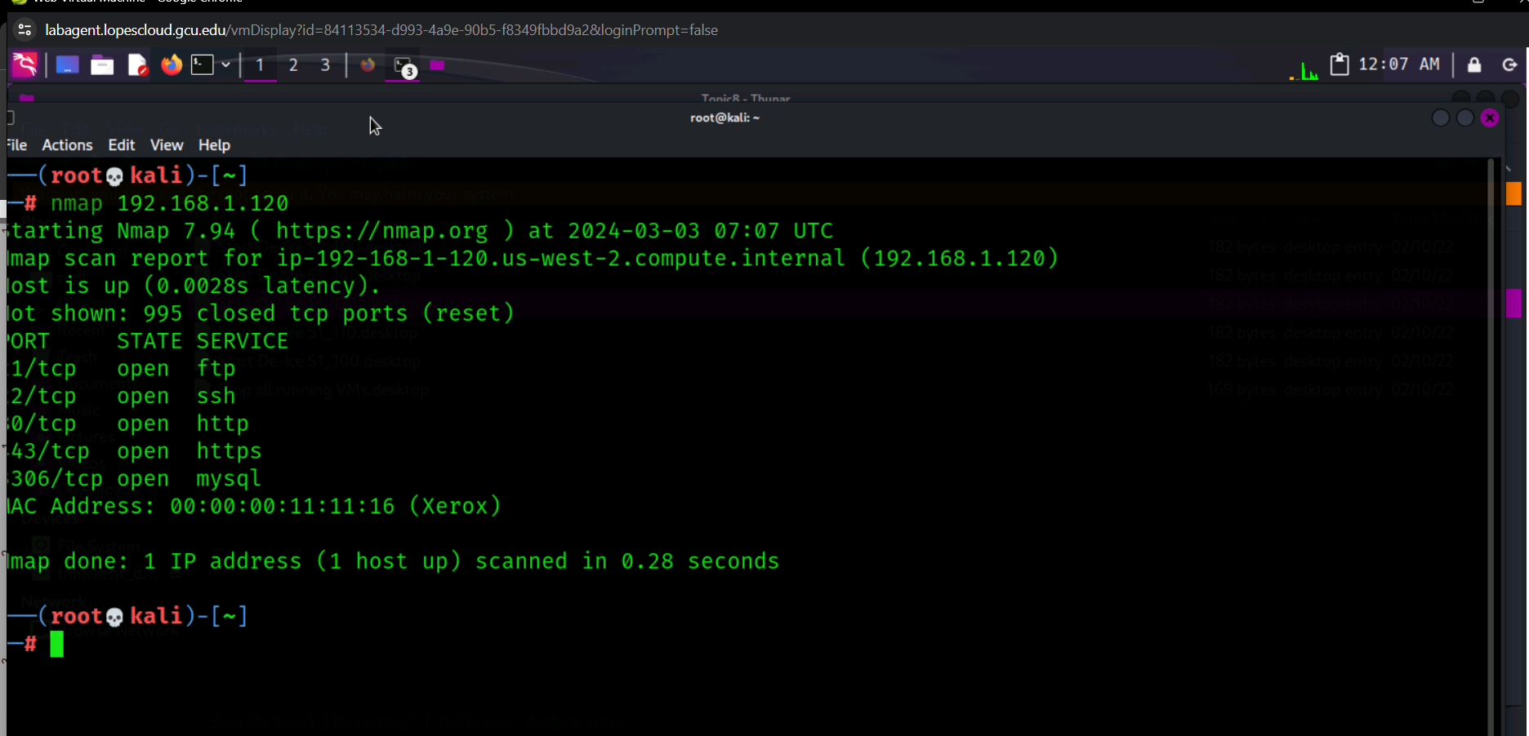

*I tried to run legion with the IP address: 192.168.1.120 and it ran three nmap tests then crashed and gave me this error (I tried 3 times but gave me the same answer).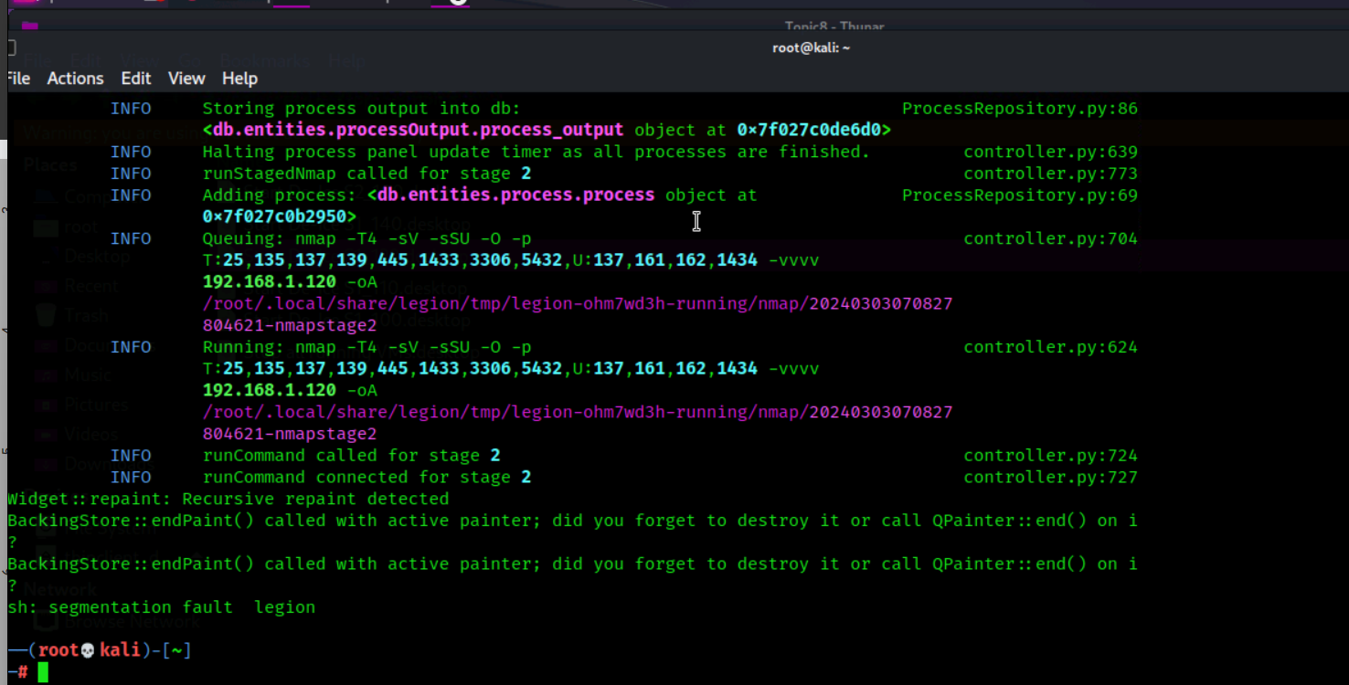*

**S1.140**

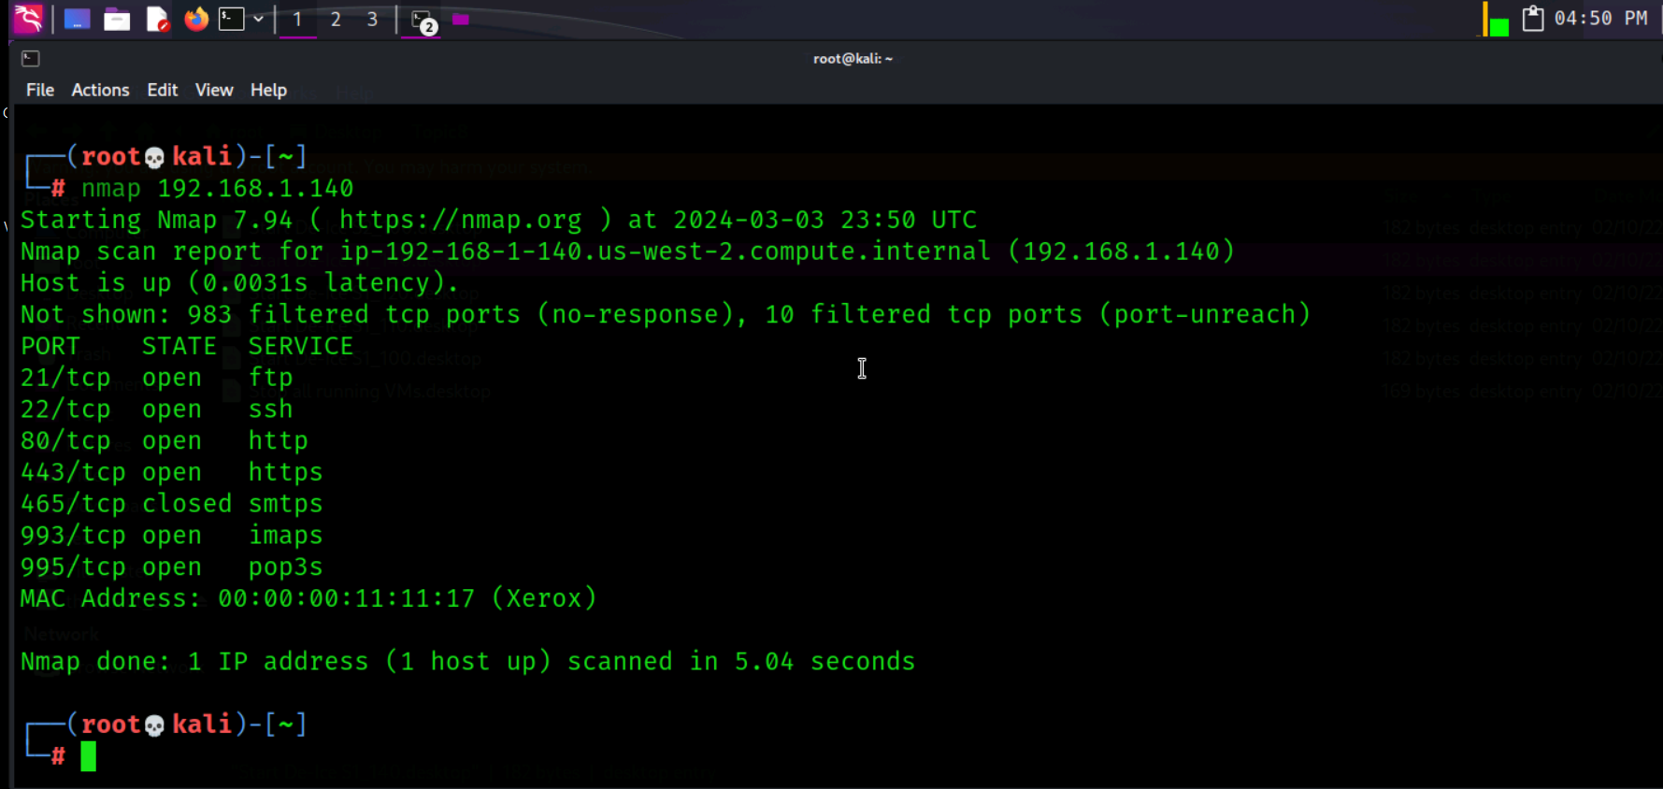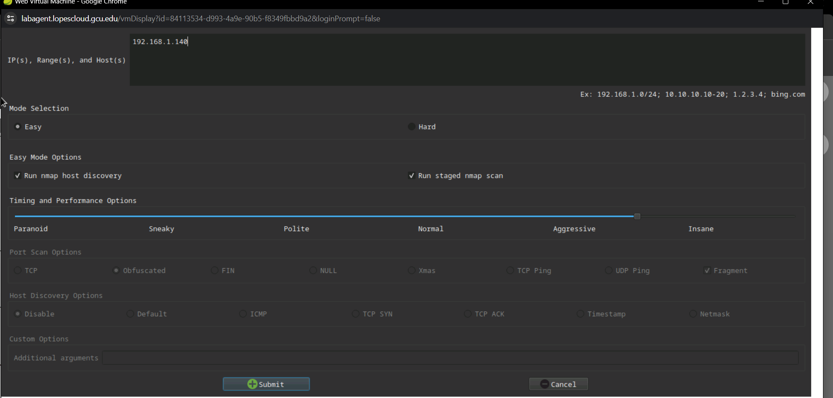

*Similar to .120, legion provided me with scans and even CVEs but then crashed, even after multiple tries.*

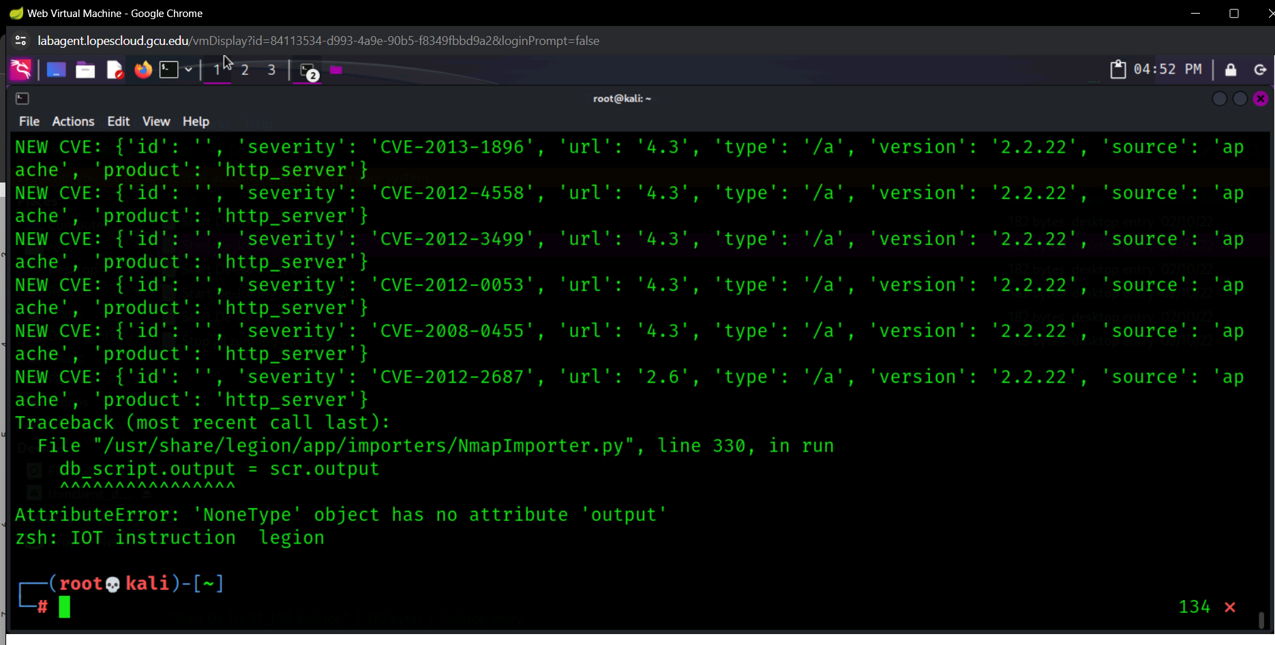

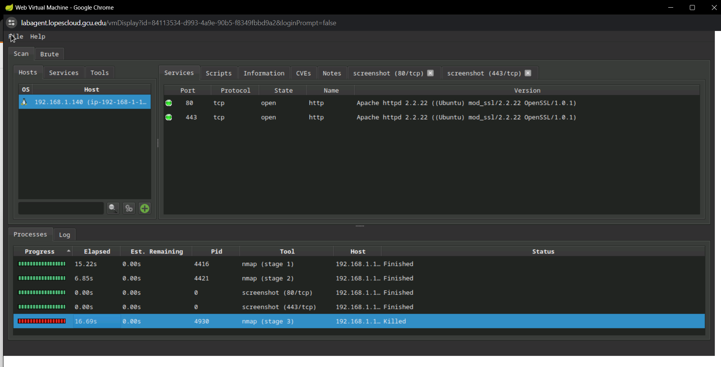



*I wanted to ping the ip address to see if the VM was the problem, but it wasn’t as it might be the missing files.*

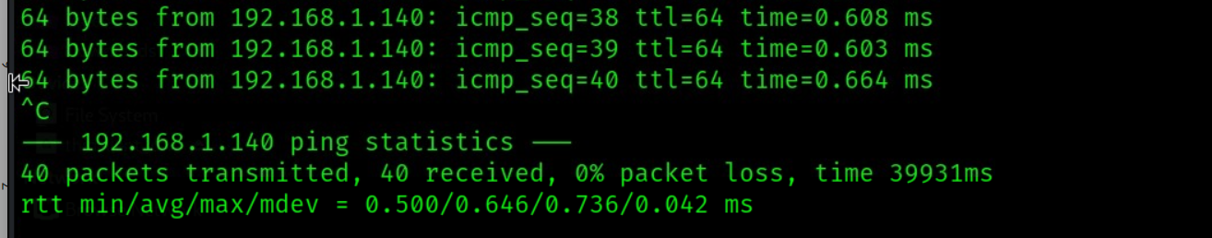

Wanted to find more details

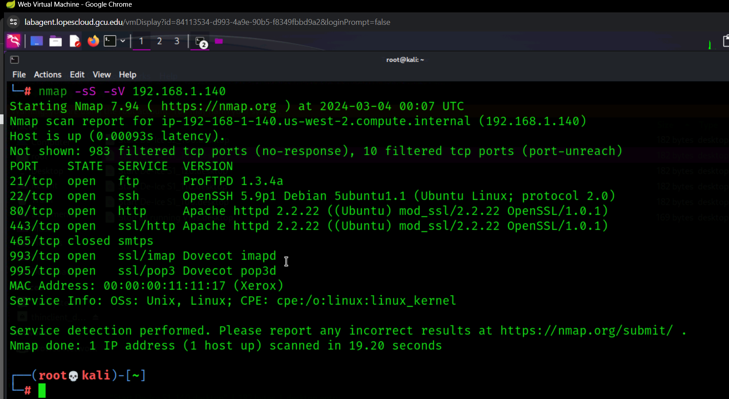

**I attempted a manual exploit using metasploit and a vulnerability that I found through metasploit.**

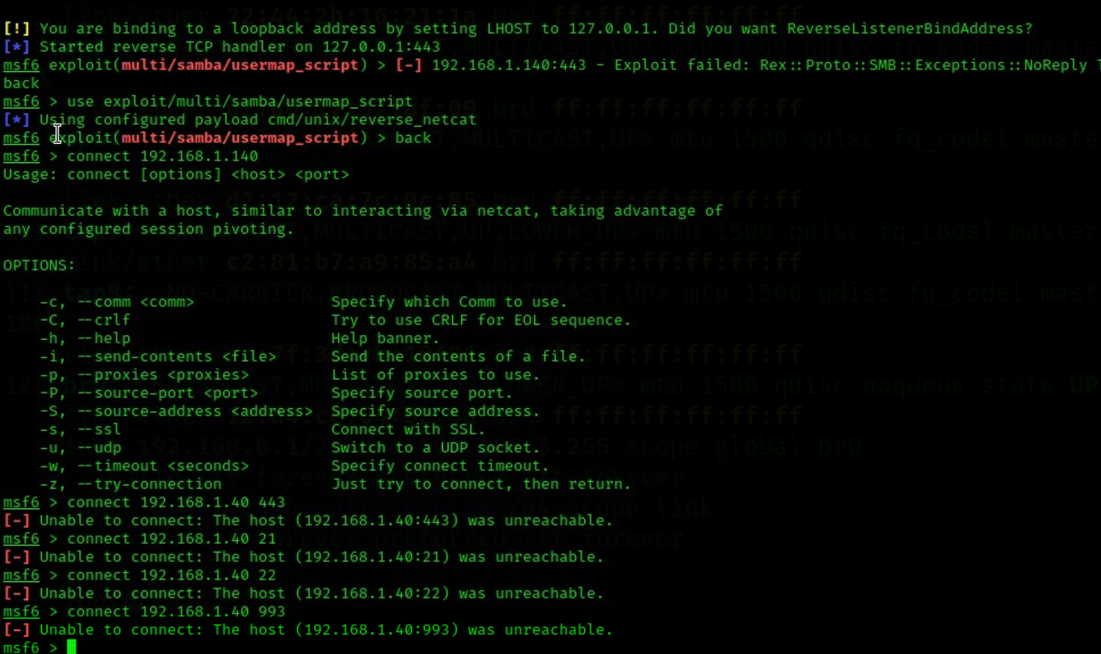

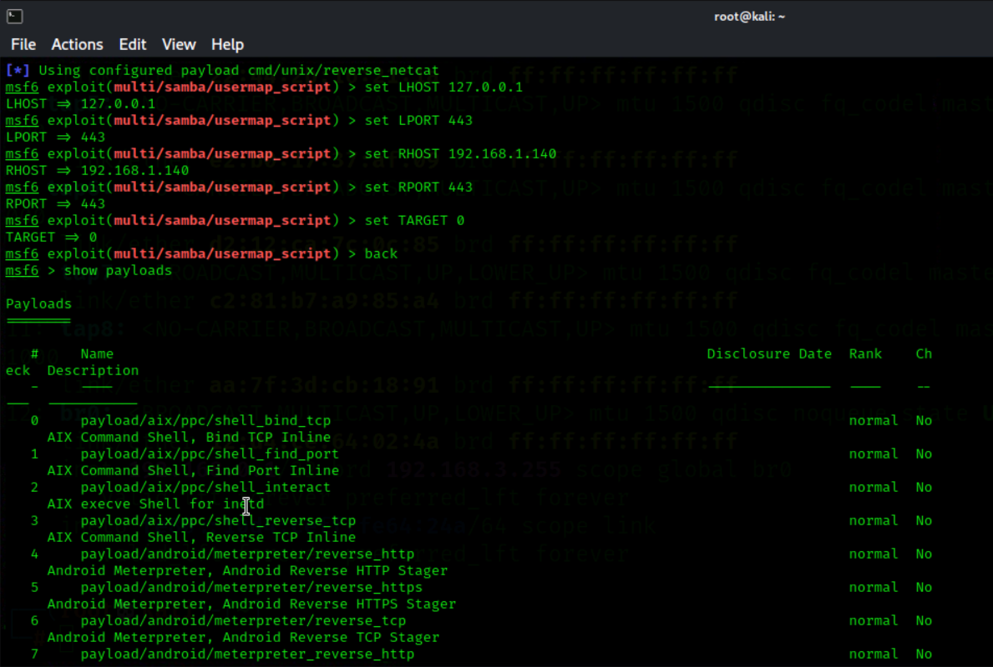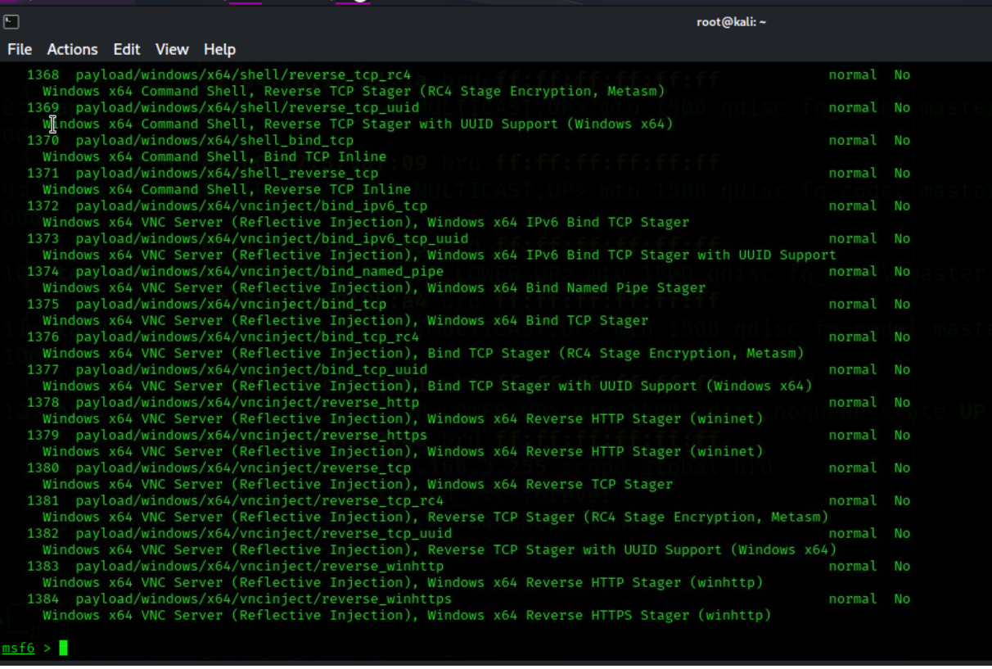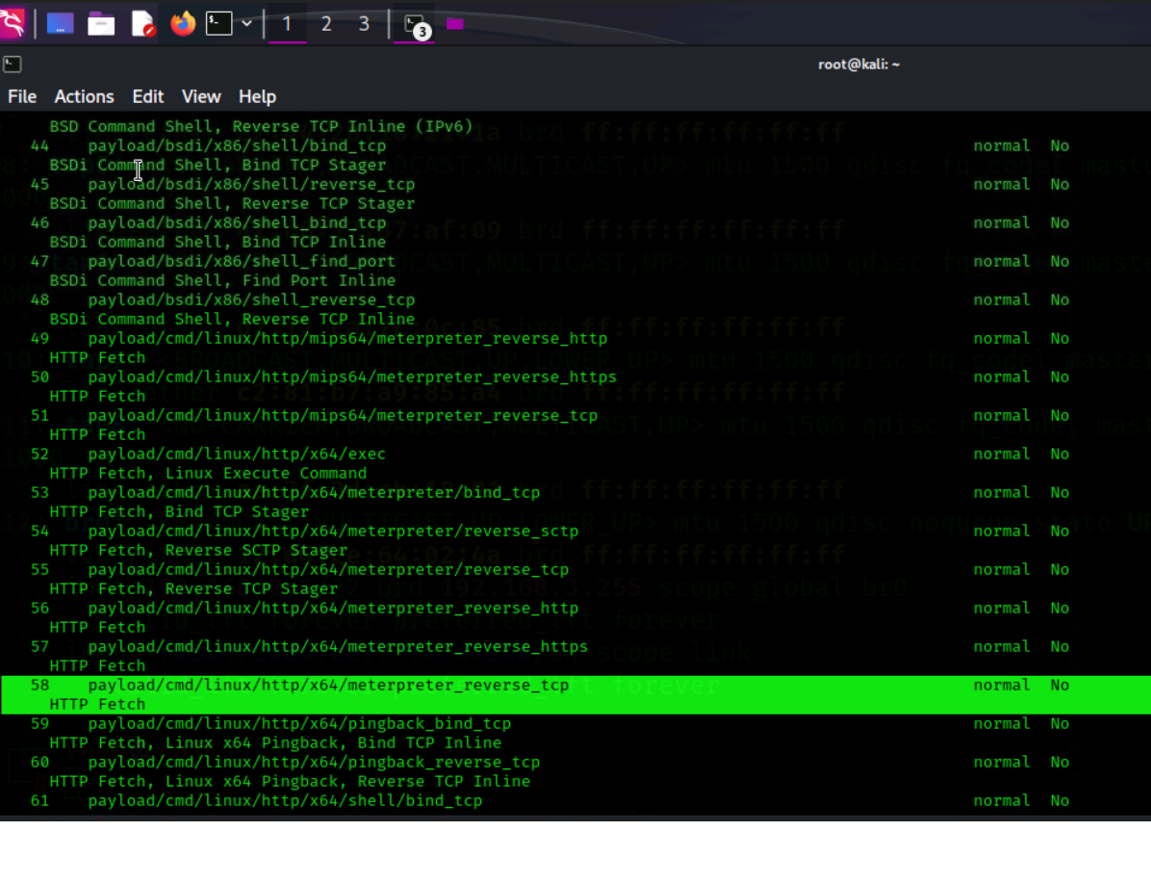

*Since the legion didn’t launch I used nikto manually.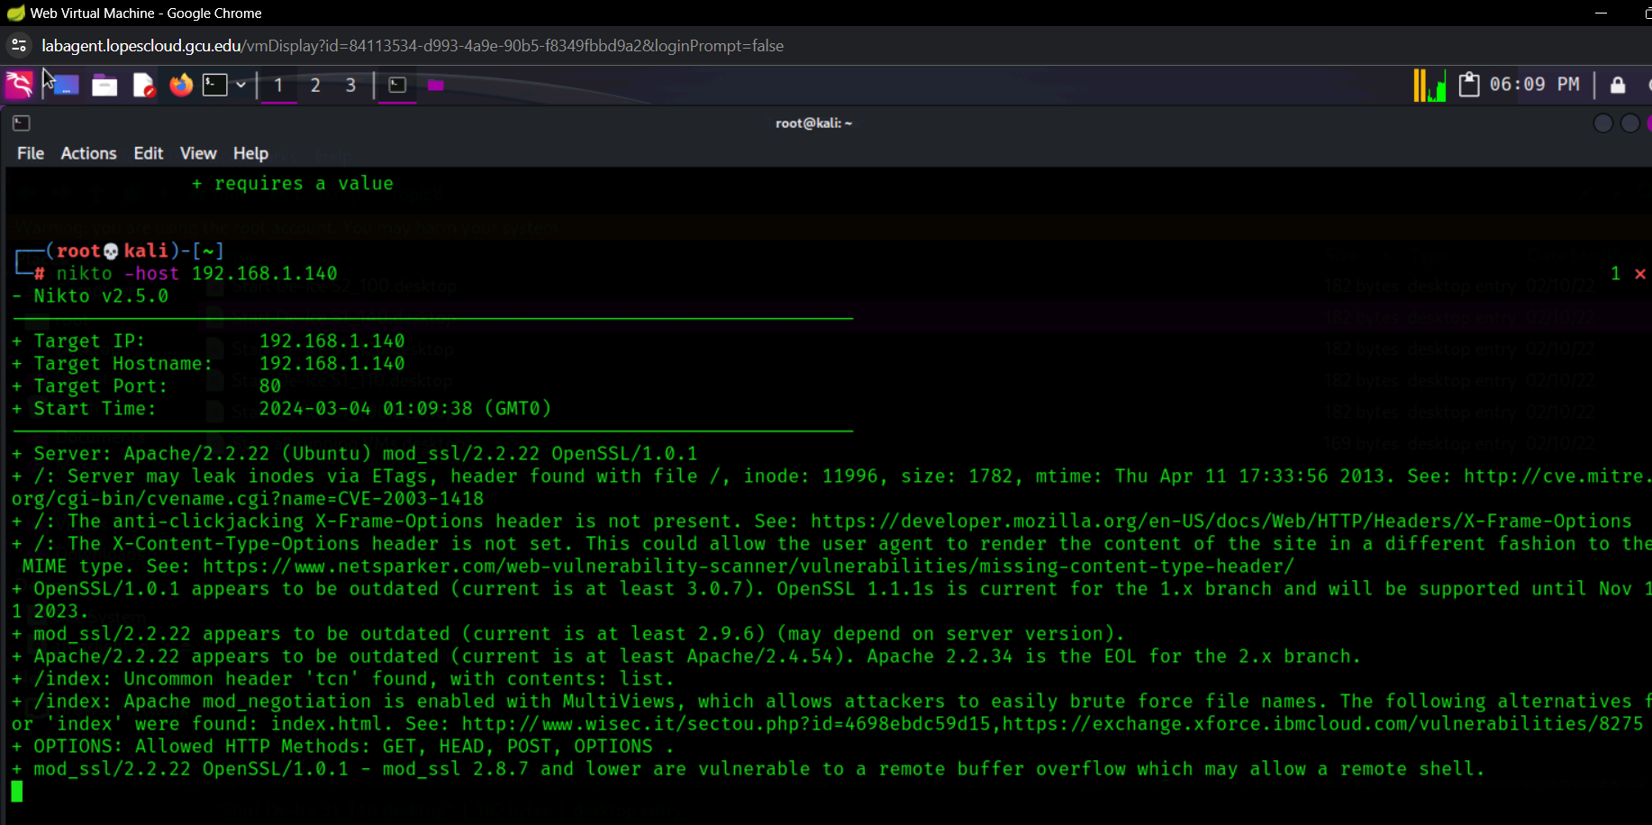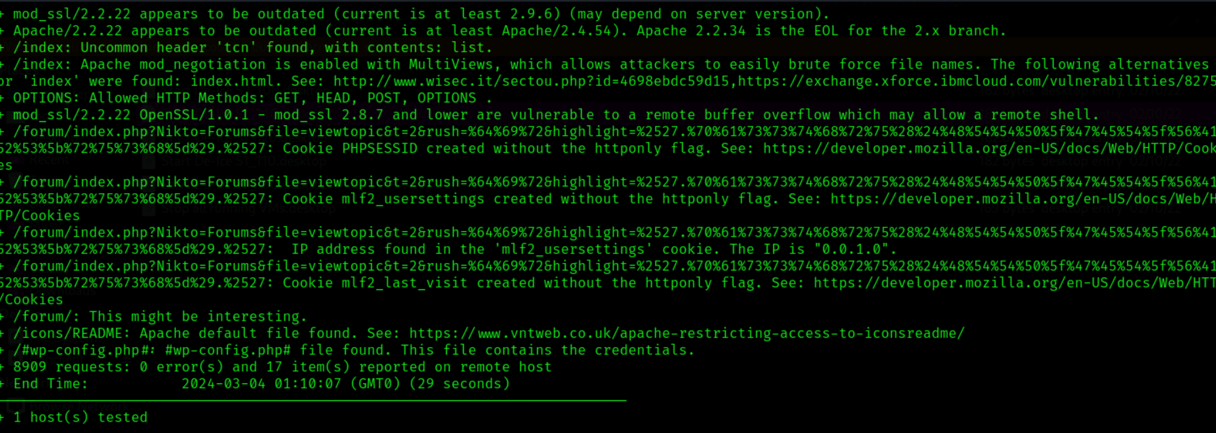*

**S.120**

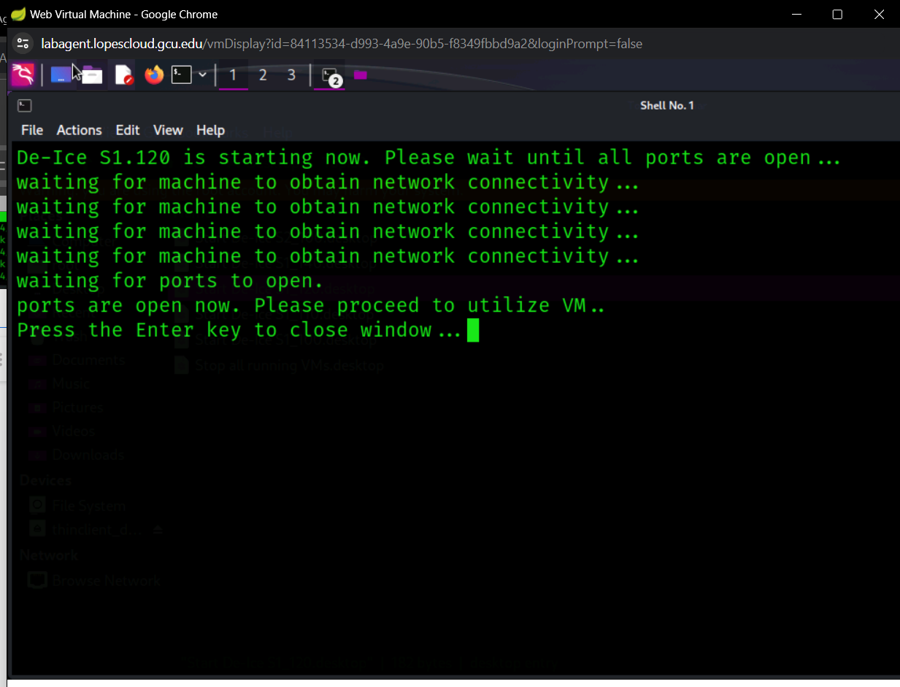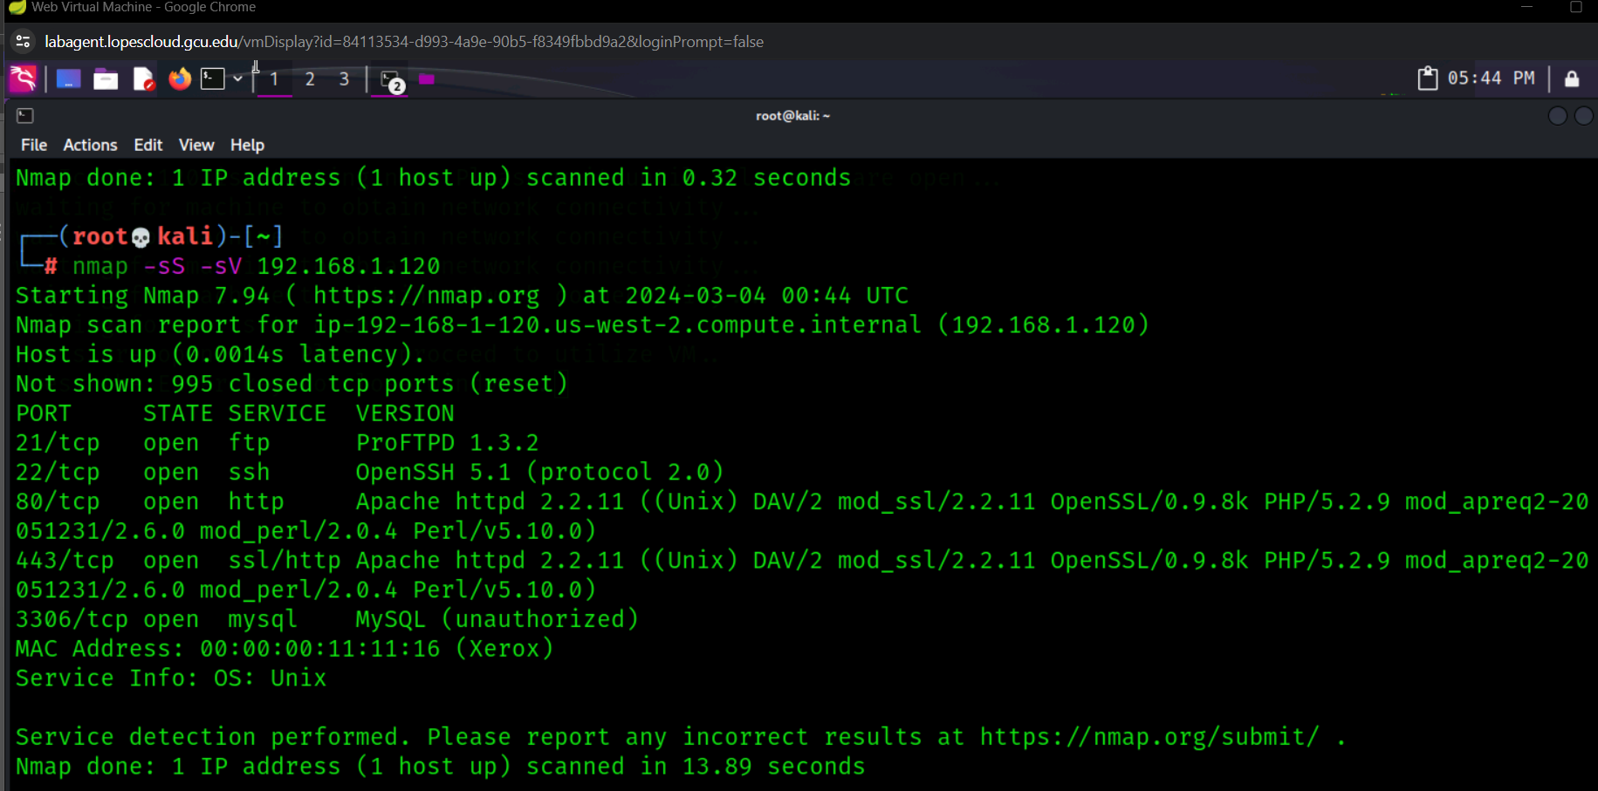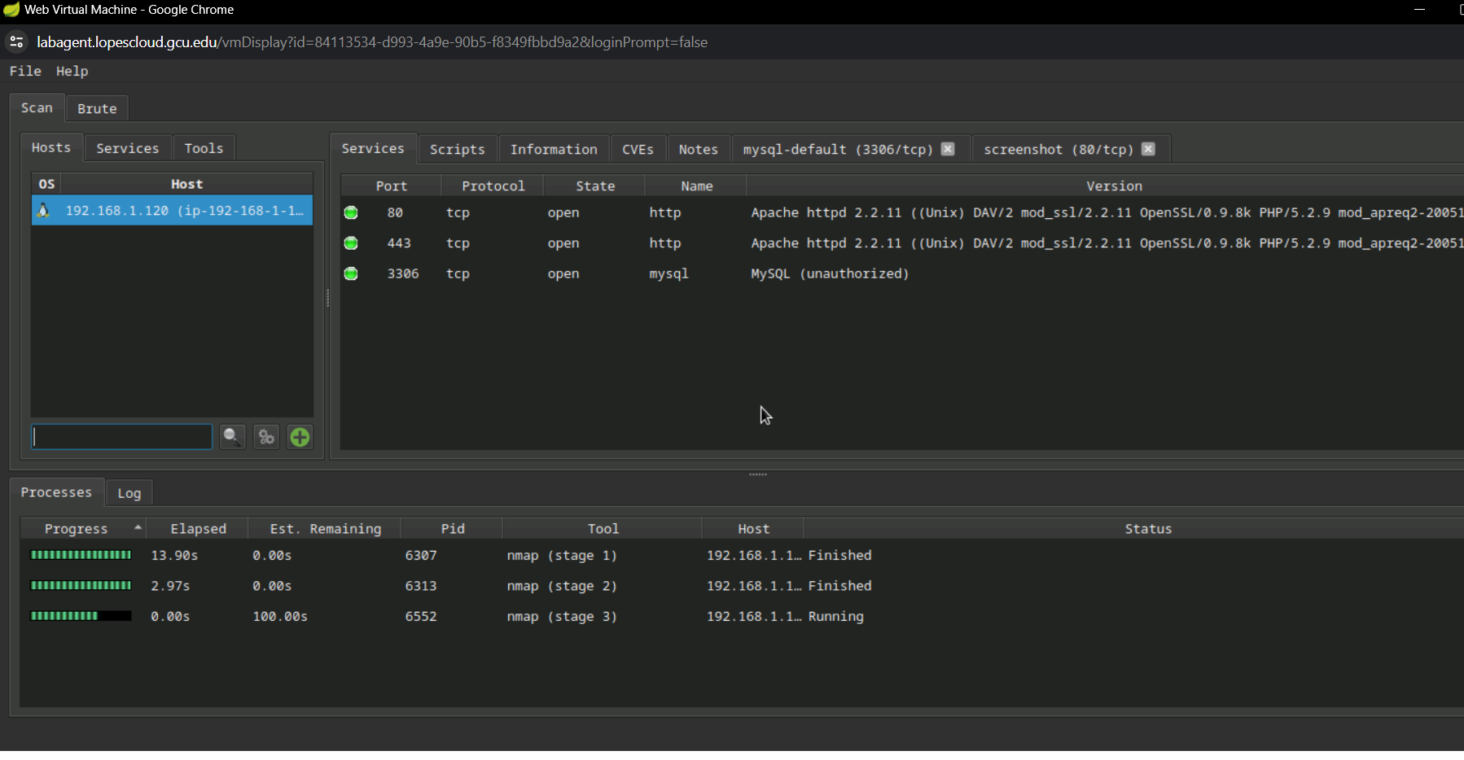

*I received a similar error but was able to kill the last scan in order to work and view the previous results.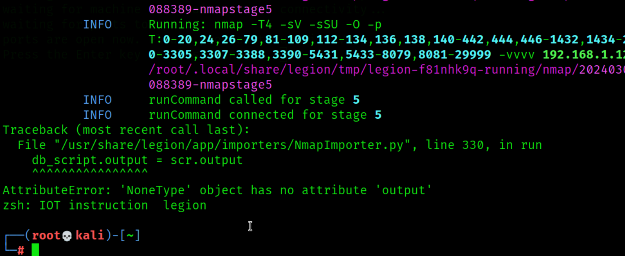*

*Did nikto manually with .120*

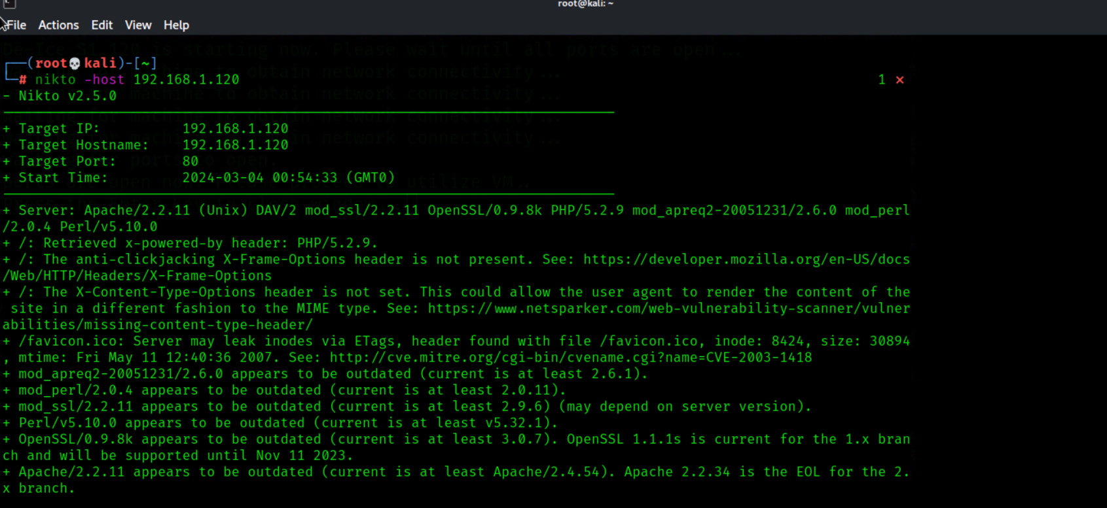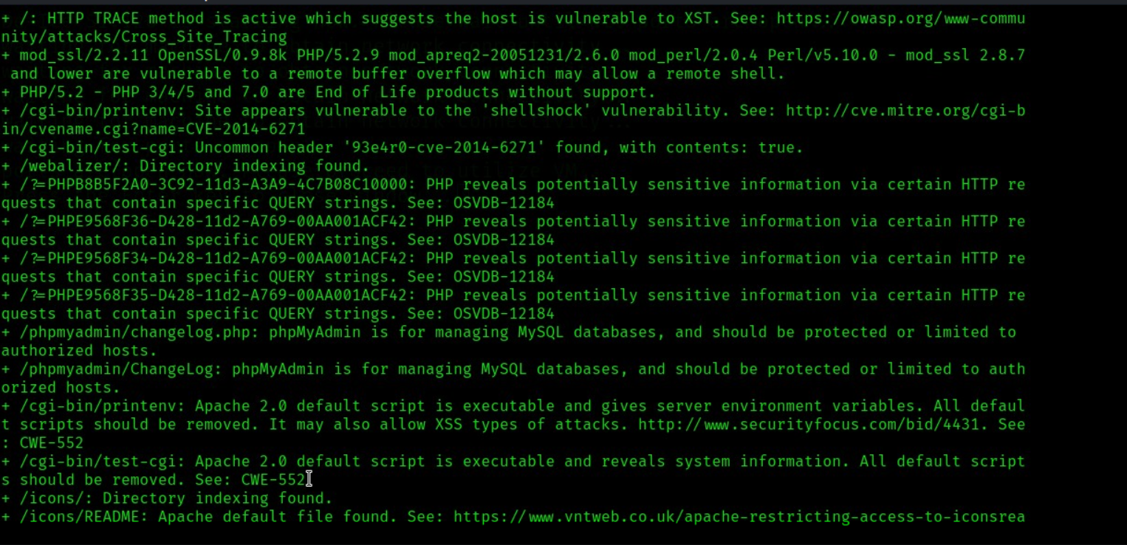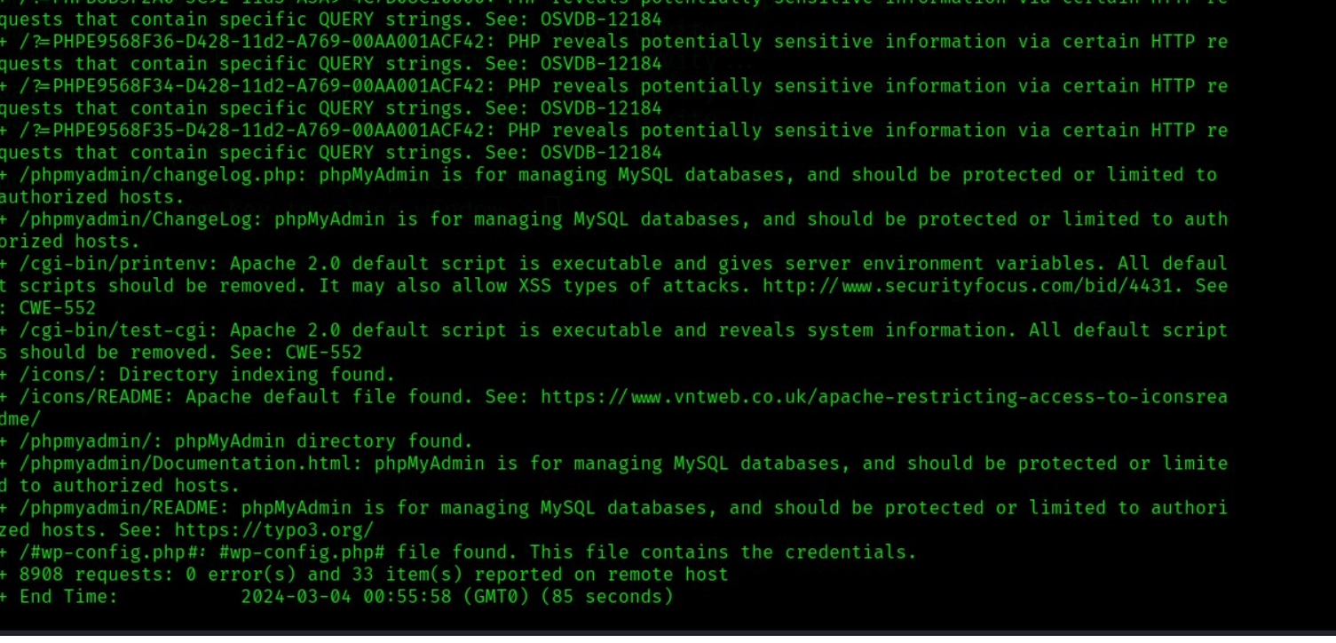

*Using one of the php vulnerabilities I was able to reach the php Admin page which provides detailed information about the website.*

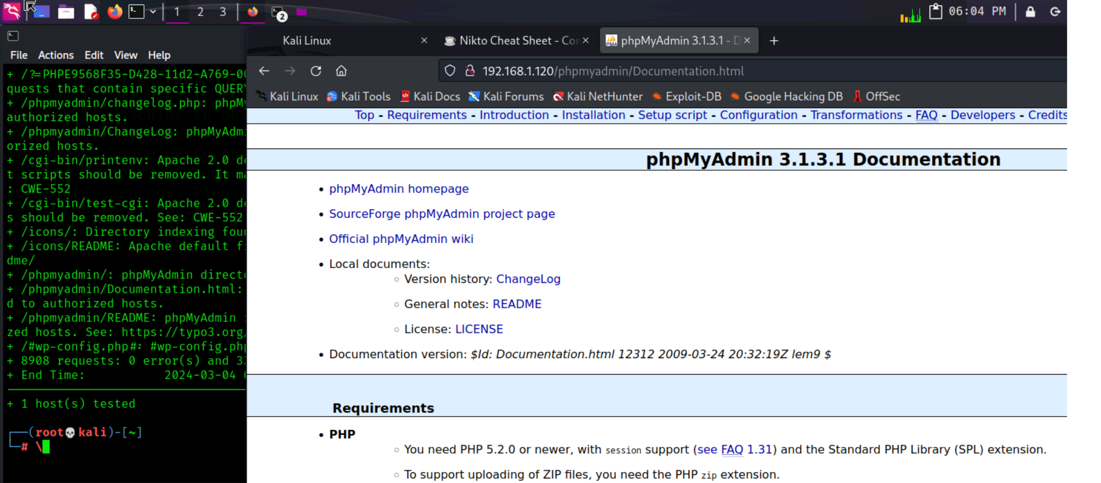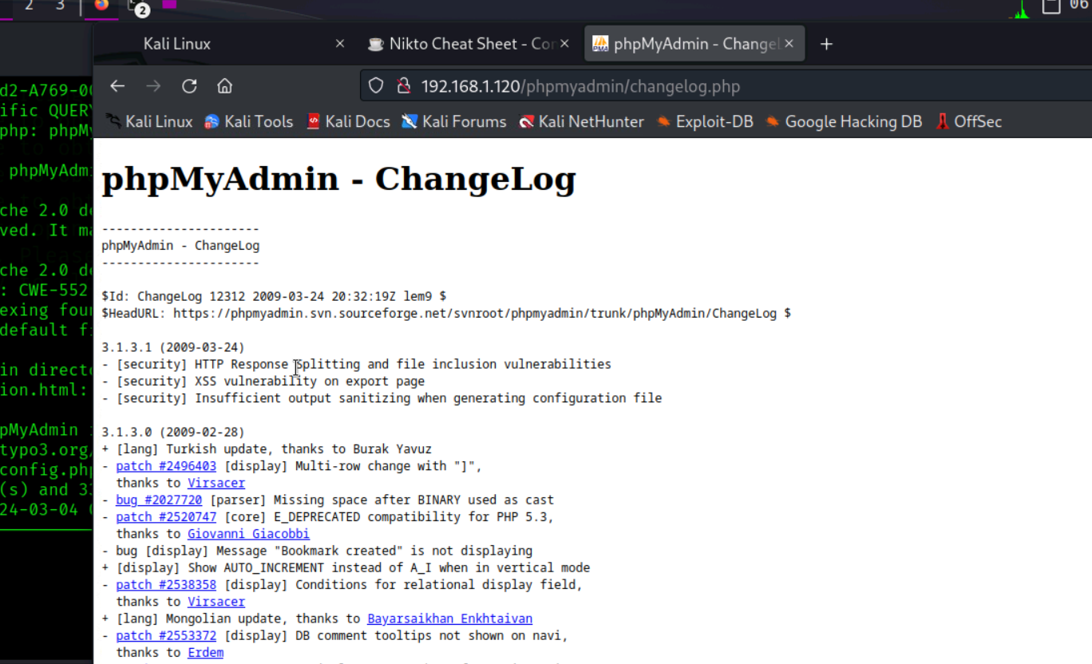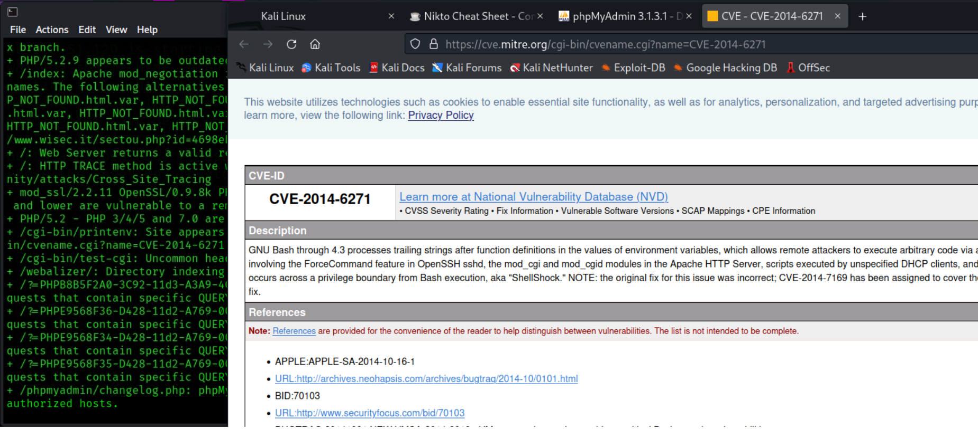

**Summary**

Through the various errors and manual procedures, it was made obvious that all 4 of these systems have multiple vulnerabilities that need to be patched and updated. Whether its failure to have sufficient security by design in the php files to ensure that the SSL is up to date.